Finance & General Purposes Committee Meeting | 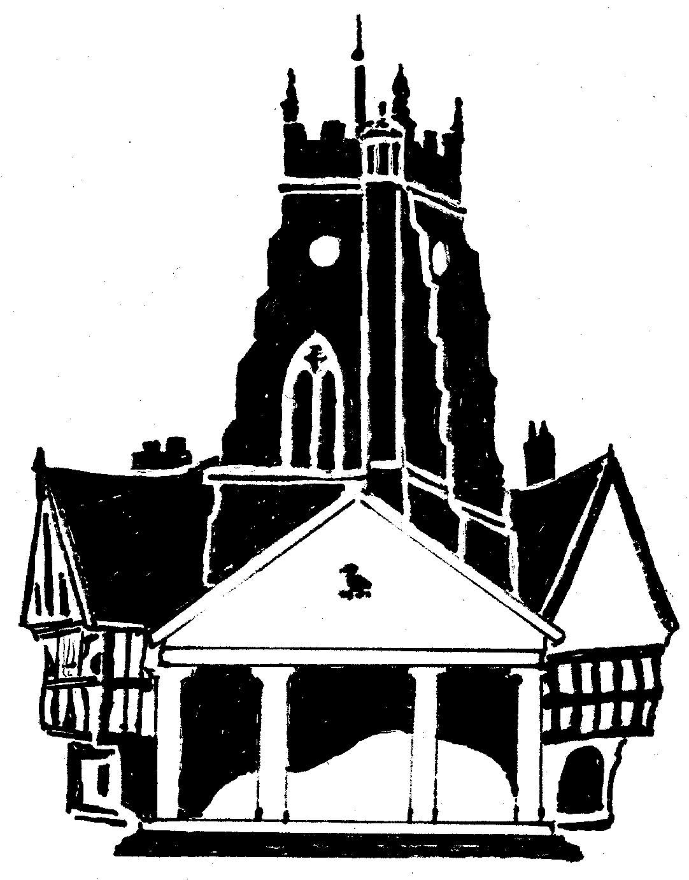  Market Drayton  Town Council
Agenda Item: 5.FG ii – Large Grants

Date: 2 November 2023

Appendix : FG96

Organisation | Requested Amount  £ | To Fund | Funded in 2022/23
- Market Drayton Choral Society | £2,000 | Payment of Musical Director, concert musicians and soloists for December 2023 and Spring Concert 2024 performances at St. Mary’s Church. | £0

