Community and Governance Committee Meeting | 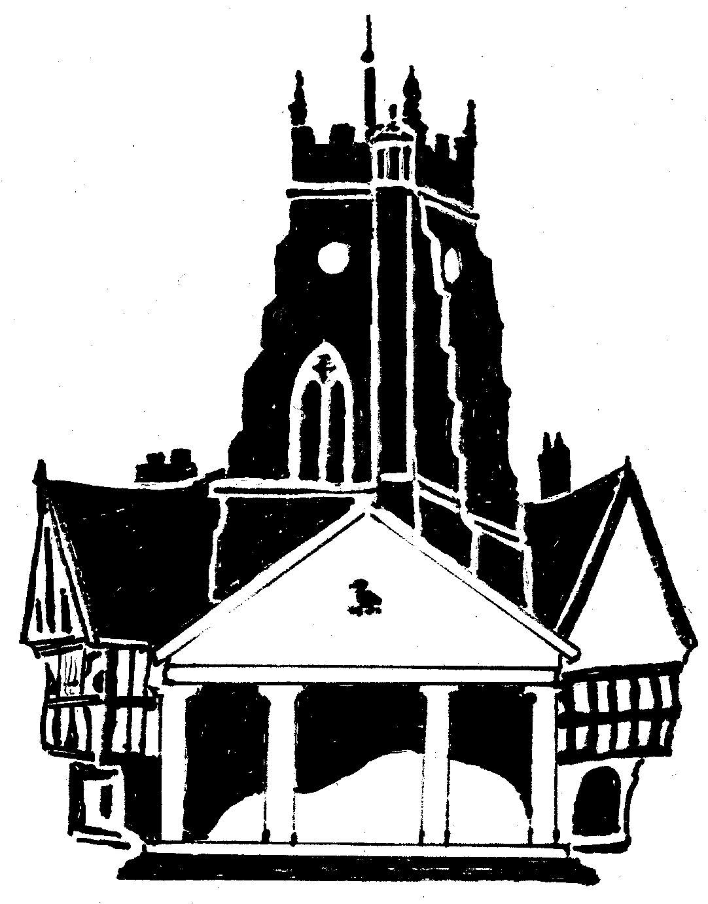  Market Drayton  Town Council
Agenda Item: 8.CG Budget 2024/25

Date: 16 November 2023

Appendix : CG105

Cost Centre 301 | Description | 2023/24 | Budget 2024/5
4017 | Police Panel | 1,500 | 1,500
4322 | Community Support and Events | 0 | 5,000 | To replace the £10,000* large grant budget currently under the Finance and General Purposes Committee. To be allocated to projects that provide support for the community and towards community events. A criteria to be produced.
4323 | Community & Governance | 5,000 | 5,000
4325 | Drayton Messenger | 8,000 | 8,000 | To be discussed
4326 | Citizens Advice Bureau | 3,000 | 6,000 | In 2023/24 £3,000 funding was allocated from budget and £1,400 from the large grant fund. An increase has been included to cover a possible increase in running costs.
4968 | Public Transport |  | 6,000 | To continue to subsidise the Saturday Town Bus Service and/or support other local transport initiatives.
4969 | Communications and Promotion |  | 4,000 | To continue to fund Visit Shropshire for another year and/or be used to promote the town.
Total |  | 17,500 | 35,500

Note: there is a proposed reduction of £10,000 under the Finance and General Purposes Committee budget.

