Services and Facilities Committee Meeting | 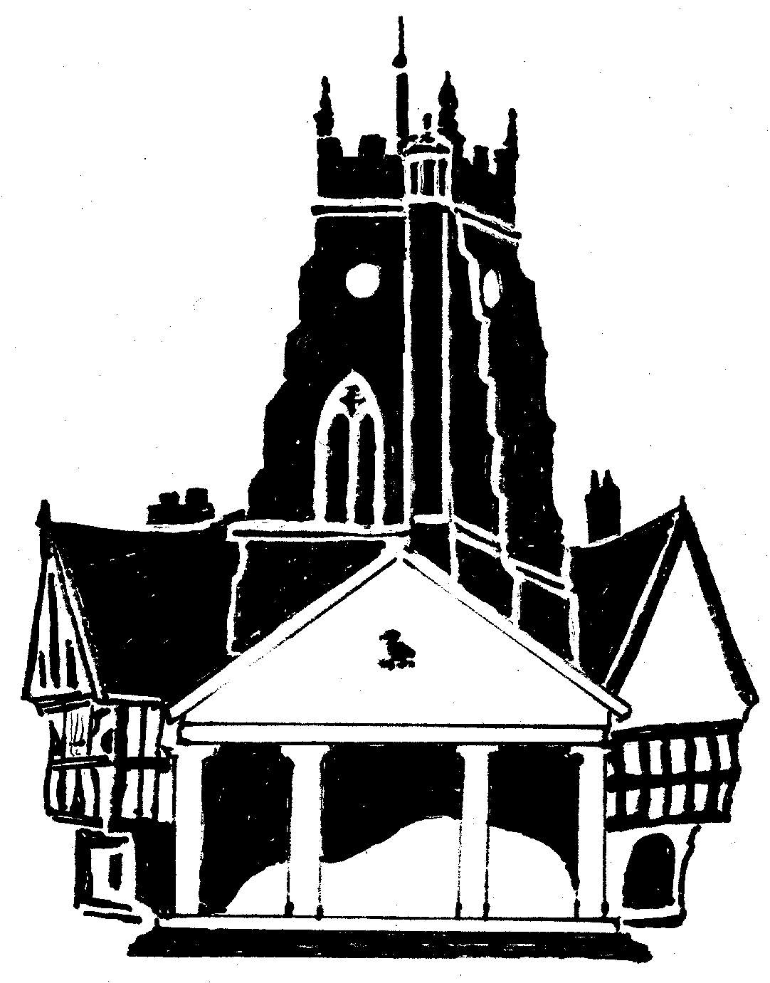  Market Drayton  Town Council
Agenda Item: 6.SF Recreation Grounds

Date: 30 November 2023

Appendix : SF110

At the Services and Facilities Committee Meeting held on the 5 October 2023 it was resolved to allocate a budget of £25,000 for the installation of a replacement piece of playground equipment on Buntingsdale with a slide and climbing bridge.
Five companies have quoted for the installation. Details of the quotes are below and pictures of the proposed equipment are attached.

Quote A | £24,999.00
Quote B | £24,966.00
Quote C | £25,000.00
Quote D | £24,996.83
Quote E | £25,000.00
Quote F | £24,993.34
Quote G | £25,000.00
Quote H | £29,684.19
Quote I | £25,000.00

