Services and Facilities Committee Meeting | 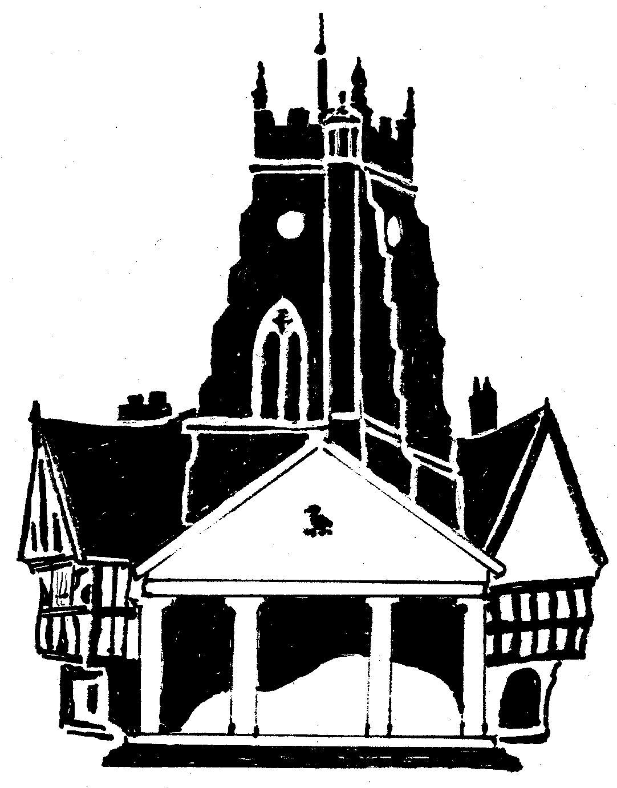  Market Drayton  Town Council
Agenda Item: 8.SF Budget 2024/25

Date: 30 November 2023

Appendix : SF111

Cost Centre | Description | Budget 2023/24 | Draft Budget 2024/25 | Explanation
101 | Street Lighting | 16,000 | 11,500 | A reduction in cost due to joining Shropshire Councils scheme for streetlights.
103 | Recreation Grounds | 93,220 | 73,890 | MDSA had an increase from £27,500 to £40,000 last financial year and £15,000 was allocated for electrical repairs. It is proposed to pay £27,500 next financial year. Grass cutting has increased from £7,000 to £15,390.
104 | Amenity Areas | 4,500 | 4,500
105 | CCTV running costs | 2,060 | 2,060
107 | In Bloom | 7,000 | 8,704 | Increase in contractor charges for floral displays and an increase of £300 for the In Bloom competition.
111 | Cemetery | 40,315 | 38,975 | A reduction in utility costs.
112 | Public Toilets | 26,600 | 27,100 | An increase of £1,500 due to an increase in the general maintenance budget.
113 | Christmas Lighting | 16,150 | 18,000 | £1,000 increase to cover the additional stall hire charges.
150 | Services & Facilities (General) | 165,000 | 180,350 | Anticipated increase in salaries. Increase in budget allocated for replacement vehicles.
Total |  | 370,845 | 365,079

