Finance & General Purposes Committee Meeting | 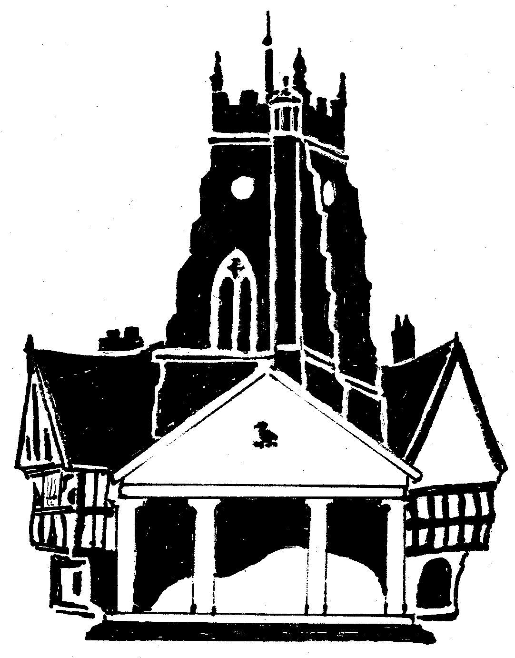  Market Drayton  Town Council
Agenda Item: 5.FG i – Small Grants

Date: 14 December 2023

Appendix : FG116

Organisation | Requested Amount  £ | To Fund | Funded in 2022/23
- Ukrainian Hub Market Drayton | £300 | Towards the hire of a minibus and petrol for two cars to allow a trip for Ukrainian refugee with children living in Market Drayton to see the Chester Zoo Christmas lights and a trip to Shrewsbury cinema to watch Ukrainian cartoons. | £0

