Extraordinary Finance and General Purposes Committee Meeting | 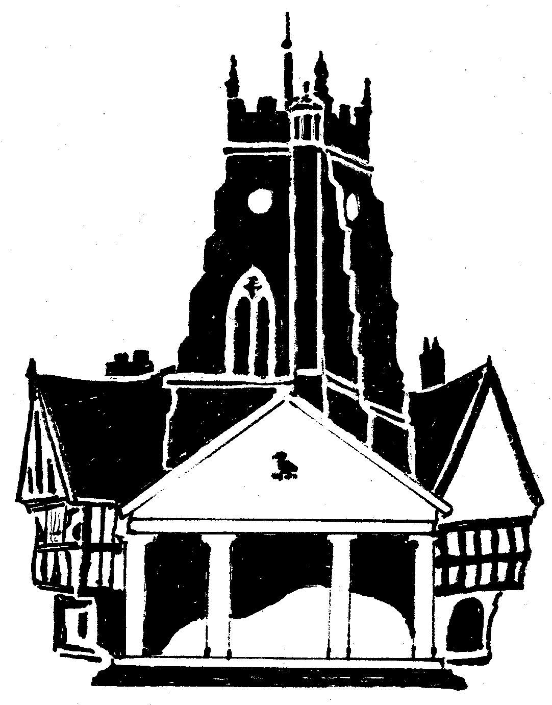  Market Drayton  Town Council
Agenda Item: Draft Finance and General Purposes Committee Budget
Date: 14 December 2023
Appendix : FG119

Cost Centre | Description | Budget 2023/24 | Draft Budget  2024/25 | Variance explanation
201 | Administration | 147,600 | 155,220 | Salary budget increase.
202 | Admin and Outside Staff Accommodation | £35,900 | 30,470 | A public loan has been repaid
203 | Civic Activities | 28,625 | 29,725 | Remembrance Sunday budget increased by £100 and an additional £1,000 towards civic regalia.
206 | Miscellaneous (PWLB) | 5,000 | 4,800
207 | Small Grants | 14,000 | 6,500 | Reduction due to the Large Grants scheme being stopped; £5,000 budget has been moved to cost centre 301 under the Community and Governance Committee to be allocated to projects that provide support for the community and towards community events.  Small Grants budget to increase from £4,000 to £6,500; maximum application limit to increase from £300 to £500.
Total |  | 231,125 | 226,715

