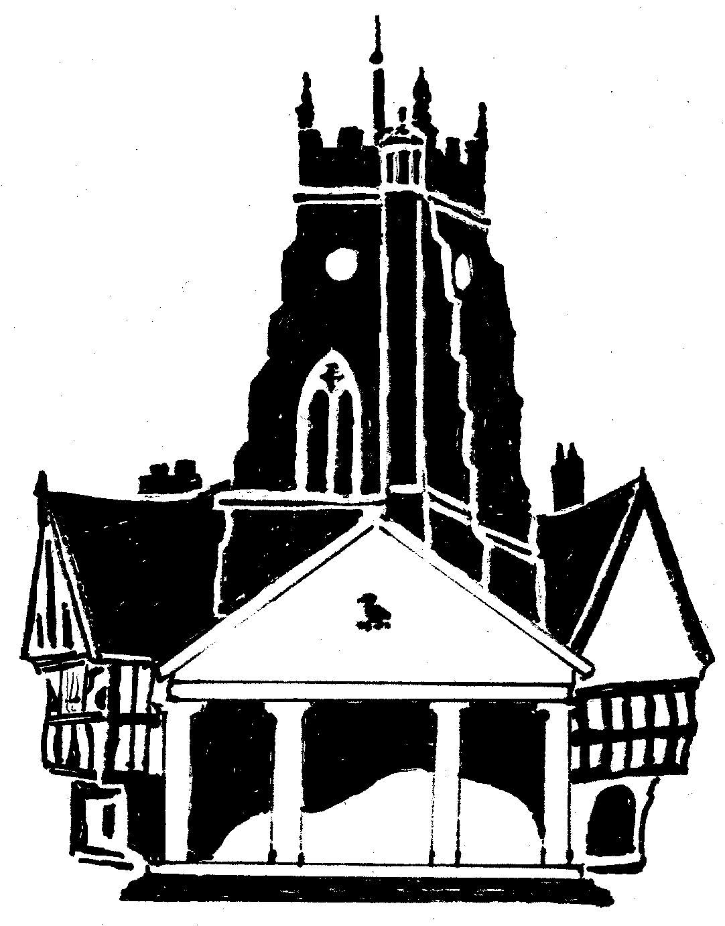

Market Drayton Town Council
Small Grants Protocol

Market Drayton Town Council has allocated £6,500 within the budget to help local organisations achieve their aims and objectives.

The Council has a policy of assisting local community groups and applications must be from a properly formed group, club, committee, or charity.

Organisations must submit a completed application form to the Clerk along with a copy of their constitution or terms of reference, which must show that the group has community aims whilst benefitting the residents of Market Drayton.

All applications of up to £500 will be considered at a Finance and General Purposes Committee meeting within the financial year.

General criteria – these apply to all Community Grant Applications:

- Each application to be considered on its merit; the amount of grant will be at the discretion of the Town Council, but will not exceed £500.
- The grant can only be used for the purposes stated and the Council reserves the right to reclaim any grant not being used for the specified purpose of the application.
- The Town Council will endeavour to treat similar projects equitably.
- The Committee will take into account any previous grant made to an organisation or group when considering a new application.
- No grant will be awarded to or for any commercial venture for private gain.
- Organisations are responsible for ensuring that they comply with all legal and statutory requirements relating to the proposed project to be funded.
- Should for any reason the organisation disband during the period of the grant the Council may ask for all or part of the monies to be paid back.
- Should the reason the grant was awarded not be completed the Council reserve the right to claim the money back.
- Organisations must have their own bank account.
- Organisations can normally only make one application per year, though exceptions can be made.
- The grant money must be used within the financial year it is given.

Adopted: Finance and General-Purpose Committee Meeting

Date: December 2023

