Services and Facilities Committee Meeting
Thursday 8 February 2024
Agenda Item: 7.SF i
Appendix: SF143

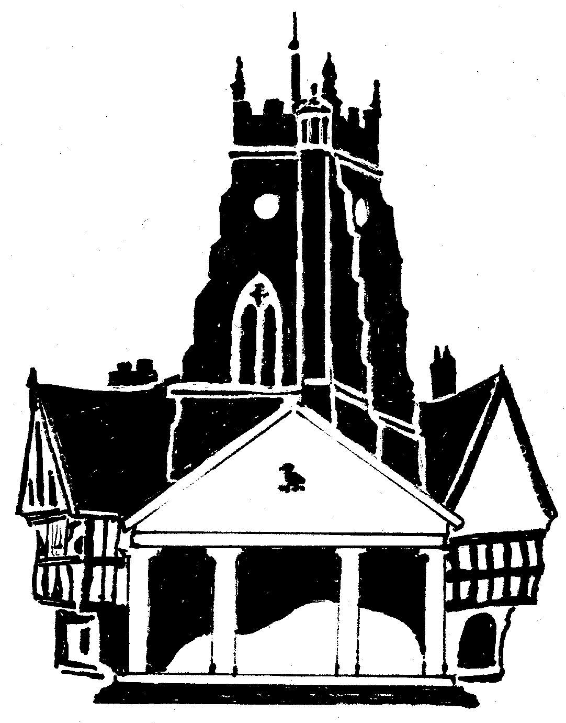

Market Drayton Town Council
Memorial Safety Policy

Introduction

This policy has been produced to set out Market Drayton Town Council’s (the Council) position with regard to memorial safety, the responsibilities of the Council, its contractors, memorial masons and Deed Holders. The policy provides an overview of the actions that will be taken to minimize risk to users of the cemetery.

Since Victorian times memorials have been erected at the head of graves as a permanent reminder of those buried within. It is often wrongly assumed that memorials are permanent structures, installed to the highest standards, and will last forever without need for repair.

The memorials do not belong to the Council; they remain the property and the responsibility of the Deed Holder to the Exclusive Rights of Burial.

Responsibilities required

The following parties have responsibility for memorial safety in Council cemeteries:

The Council has health and safety responsibilities to its employees, contractors and visitors to cemeteries. The council has a responsibility to staff (Section 2 Health and Safety at Work Act 1974) and a responsibility to visitors (Section 3 Health and Safety at Work Act 1974). The Management of Health and Safety at Work Regulations 1999 places a legal duty on the council to assess the risks from cemetery structures and work activities and ensure that the risks are controlled.

A monumental mason has the responsibility to work in accordance with the Council’s conditions and specifications for memorials as described in the Cemeteries’ Rules. The Council adheres to BS8415 and the National Association of Memorial Mason Standards (NAMM) for the fixing of memorials. All memorials must be installed to these standards.

The Deed Holder or successor in title, of a memorial has the ultimate responsibility to maintain it so as not to present a hazard to themselves, members of the public or cemetery staff, and as such are therefore responsible and liable for all expenditure incurred to make safe their memorial in the event that their memorial is found to be unsafe or dangerous condition. This is not the responsibility of the Council.

Notice of intent

Prior to any memorials being inspected, reasonable steps will be taken by the Council to inform grave owners, Deed Holders or successors in title, and members of the public, of the intention to inspect memorials and reducing the risk posed by unsafe memorials.

This will involve:
Giving advanced notice, of an inspection regime. Placing public notices on the cemetery gates, Town Council noticeboards and website, on facebook and in prominent locations elsewhere in the cemetery affected by the assessment regime.

Formal Inspection Programme

Inspections will be carried out every five years.

All individuals carrying out memorial safety inspections at the Cemetery must have attended a training course on the subject and obtained certificates of competence which will be held on their personnel file.

A memorial is only considered as unsafe if it moves and will continue to move until it falls to the floor, under an initial firm but reasonable force approximating 25k. All memorials will be assessed in accordance with the MoJ Guidance 2009 and a profile of risk will be developed for memorials within the cemetery. The profile will provide a focus for subsequent inspection work as follows:

Category 1 High Risk – There is movement and memorial is not safe. Immediate action is required to make the memorial safe or to stop the public accessing the memorial. This could be the permanent removal of the hazard or the temporary making safe of the hazard. Notify owner and ask them to make repairs employing a qualified stone mason with a 6 month period.

Category 2 Medium Risk –The memorial is not an immediate danger to the public but is not fully stable and will, therefore, need to be monitored every 12 months to assess any further deterioration. Owner to be notified suggesting memorial mason makes it safe to avoid memorial becoming further weakened.

Category 3 Low Risk – The memorial is perfectly stable or below 625mm

Memorial Make-safe, Repair or Re-fixing

The Local Authorities Cemetery Order 1977 (LACO 77), Article 3(2)(b) does not authorise “any action in relation to any vault, or any tombstone or other memorial, other than action which is necessary to remover a danger which arises by reason of the condition of the vault, or the tombstone or other memorial, itself”

Article 16(2) provides powers to remove dilapidated memorials where inscriptions are illegible due to neglect.

Where a memorial is found to be unstable, is considered an immediate danger and could cause a serious injury, then suitable make safe methods will be considered and implemented.

Such memorials will have warning notices placed on them and may be either :
- set in the ground
- cordoned off
- temporarily supported
- re-fixed using jointing compound
- repaired to BS8415 or NAMM Code
- laid down

Decisions of how each memorial is treated will be dependent on the type of memorial and an individual assessment.

Any requirement to make-safe, repair or re-fix a memorial shall be notified to the grave owner, where they can be identified, and they will be asked to make the memorial safe.

Any temporary supports shall be left in place only whilst attempts are made to contact the owner of the exclusive rights of burial in the grave. Supports will be removed and alternative methods of making safe the memorial will be used after a maximum of 12 months.

Memorials which fail the test and are temporarily made safe, will be inspected again one year from the make safe date. Informal visual inspections will also be carried out by council staff during their normal working days i.e. locally to where graves are being dug and grass cutting operations are taking place; should any memorials fail these random visual tests the employee or contractor will report their findings to the Town Clerk.

All repairs or re-fixing that requires the work to be carried out by a NAMM registered stonemason, shall be carried out in accordance with BS8415 and/or the NAMM Code of Working Practice. Where a semi-permanent re-fix is required, using an approved jointing compound, this shall be carried out by staff who have been trained to carry out such work.

Communication

The Council is aware that memorial testing is a sensitive issue for those involved. Regular communication will be maintained so that the general public, staff and members are aware and understand each stage of the testing process.

Communication will take place through:

- The Council’s website and noticeboards
- Signage on the Cemetery gate and within the cemetery
- Facebook

