Community and Services Committee Meeting | 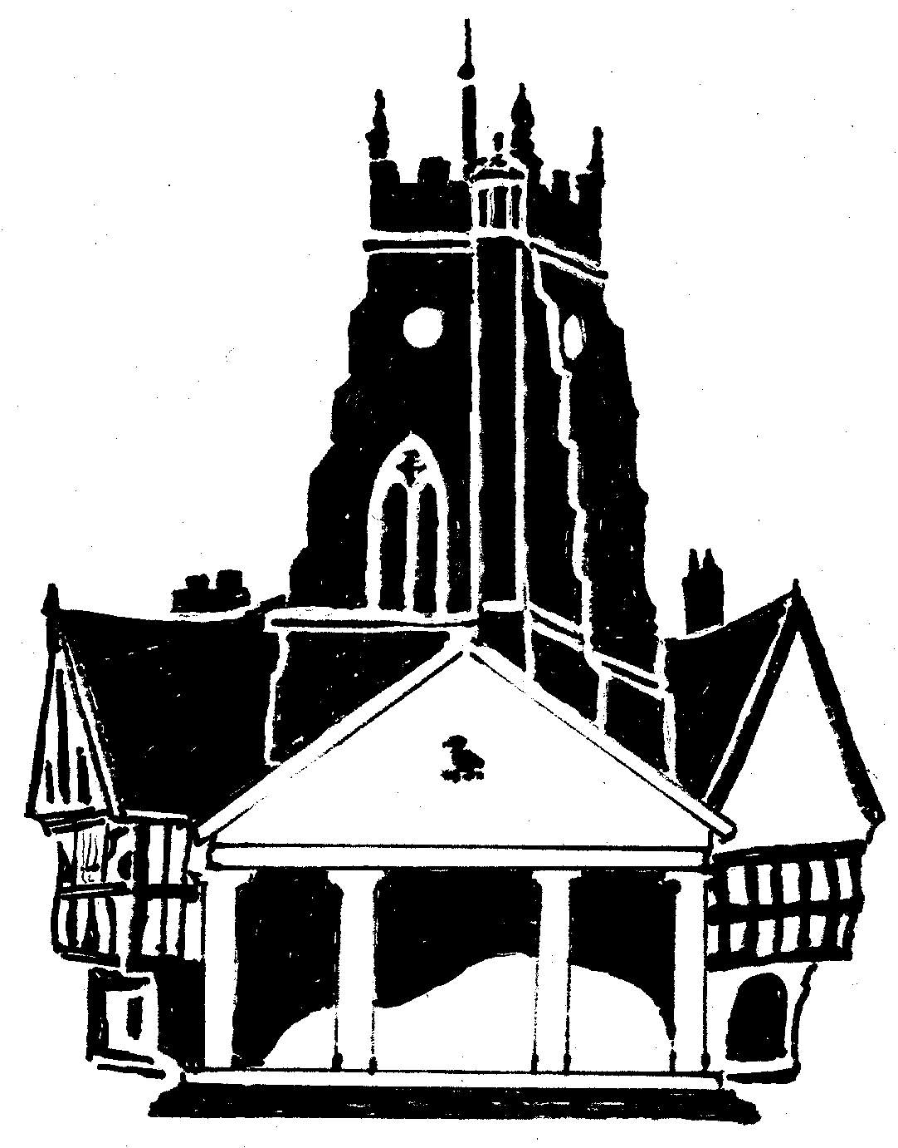  Market Drayton  Town Council
Agenda Item: 8.CG D-Day

Date: 7 March 2024

Appendix : CG157

80th Anniversary of D-Day, 6th June 2024

The following events are being organised to commemorate the 80th anniversary of D-Day by the Royal British Legion, with support from the Town Council.
Details of the guidance can be found at: https://static1.squarespace.com/static/640a0ac2b261e5337f7adb4e/t/65be3c65b8be025f302acaad/1706966158657/D-Day+80+Anniversary+Guide+v148.pdf

Thursday 6th June 2023
8am D-Day reading of the Proclamation by the Town Crier
11am D-Day Heroes Poem to be read out at schools
9.10pm Reading of the Proclamation and the International Tribute
9.15pm Bugler playing and lighting of the beacon (location to be confirmed)

Sunday 9th June 2023
TBC Church Service at St Marys Church
TBC Wreath Laying and short service at the War Memorial

For Consideration
To agree to allocate £500 budget towards the D-Day events taking place on 6th and 9th June.

