Community and Services Committee Meeting | 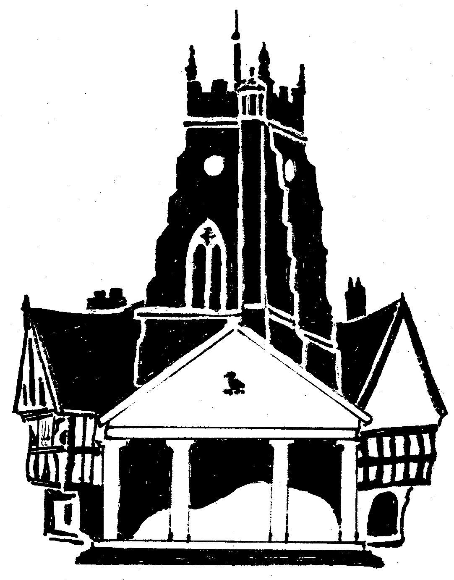  Market Drayton  Town Council
Agenda Item: 6.CGi Town Centre Working Group

Date: 7 March 2024

Appendix : CG154

Town Centre street furniture Audit 22/1/24
The following audit was undertaken to determine the works that were necessary to improve the appearance and suitability of our current Street furniture within the Town Centre. The Audit to include Fingerposts, waste bins, bollard, seating and information boards.
The proposed new/replacement arms are in bold.
All the fingerposts would benefit from a clean, in some cases repainting, and some of the arms need realignment.
Fingerposts
Stafford Street
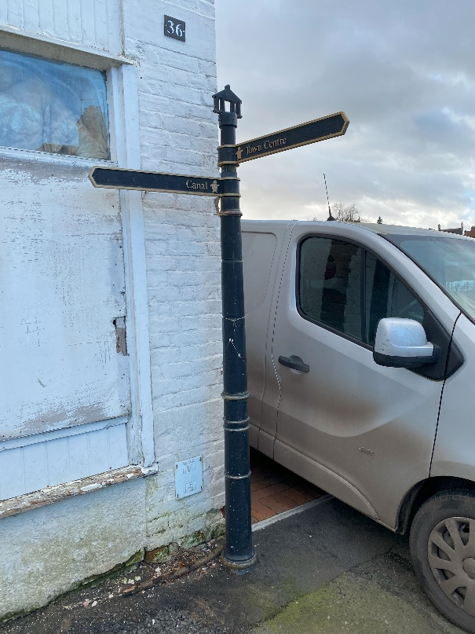
Current Signage | Proposed Signage
Town Centre | Town Centre
Canal | Canal
No sign | Town Centre

Current Signage | Proposed Signage
Canal | Canal
Toilets | Toilets
Customer First  Library | Town Centre  Library
Bus Station  Primary Care Centre | Bus Station  Health Centre
Royal British Legion Club | Royal British Legion Club
Festival Drayton Centre  Town Hall  Town Park | Festival Drayton Centre  Town Hall  Town Park
Sign broken off | St Mary’s Church
Sign broken off | Street Market (Wed)  Buttercross

High Street
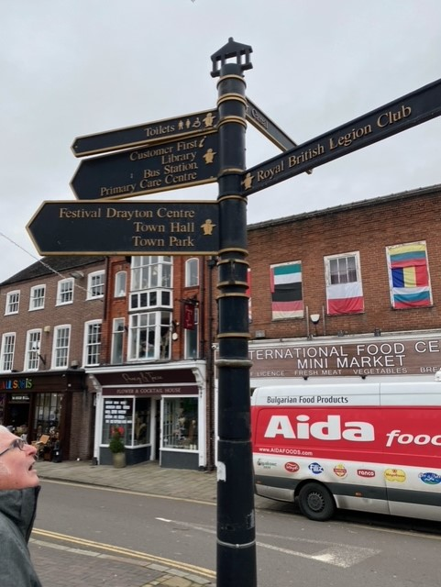

Great Hales Street

Current Signage | Proposed Signage
Town Centre  St Marys Church | Town Centre  St Marys Church
Swimming Pool | Swimming Pool

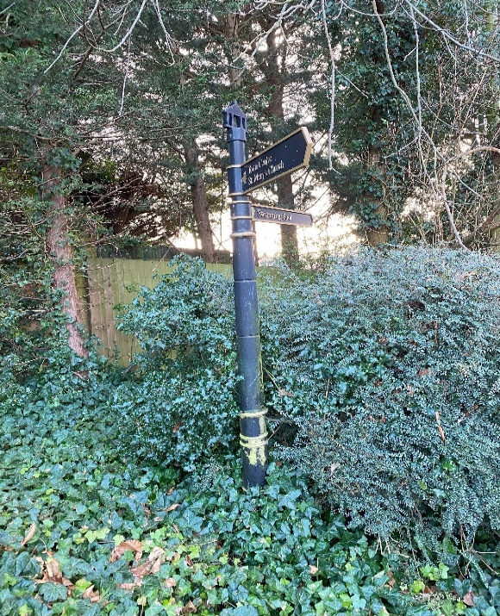

Frogmore Road
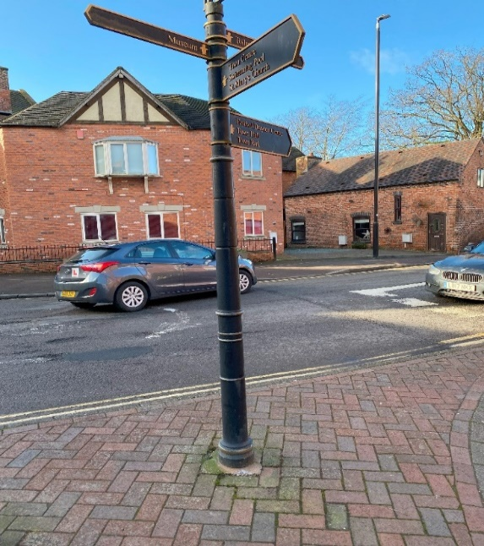
Current Signage | Proposed Signage
Toilets | Toilets
Museum | Museum
Town Centre  Swimming Pool  St Marys Church | Town Centre  Swimming Pool  St Marys Church
Festival Drayton Centre  Town Hall  Town Park | Festival Drayton Centre  Town Hall  Town Park

Current Signage | Proposed Signage
Town Park | Town Park
Customer First  Library  Town Centre | Library  Town Centre
Bus Station  Primary Care Centre | Bus Station  Primary Care Centre
Toilets | Toilets
Festival Drayton Centre  Town Hall  Museum | Festival Drayton Centre  Town Hall  Museum

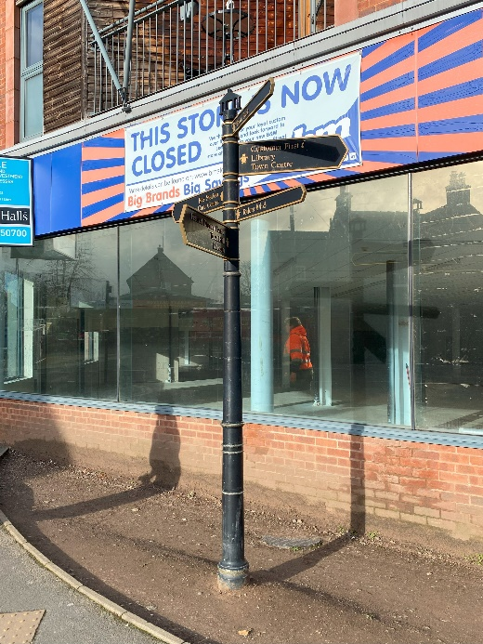
Cheshire Street
Current Signage | Proposed Signage
Toilets | Toilets
customer First  Library  Bus Station  Primary Care Centre | Library  Bus Station  Health Centre
Festival Centre  Town Hall  Town Park | Festival Centre  Town Hall  Town Park
Sign broken off | Museum
Sign broken off | Indoor Market

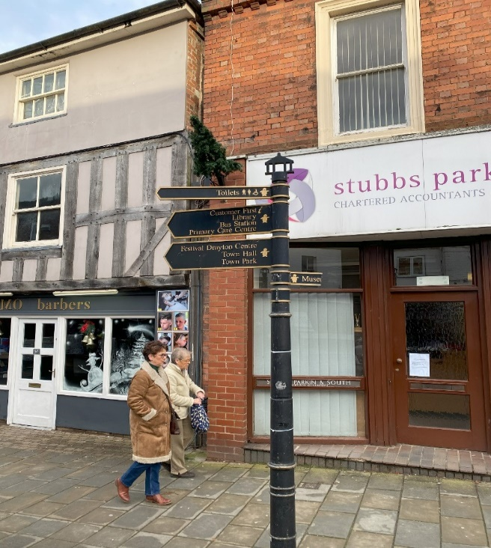

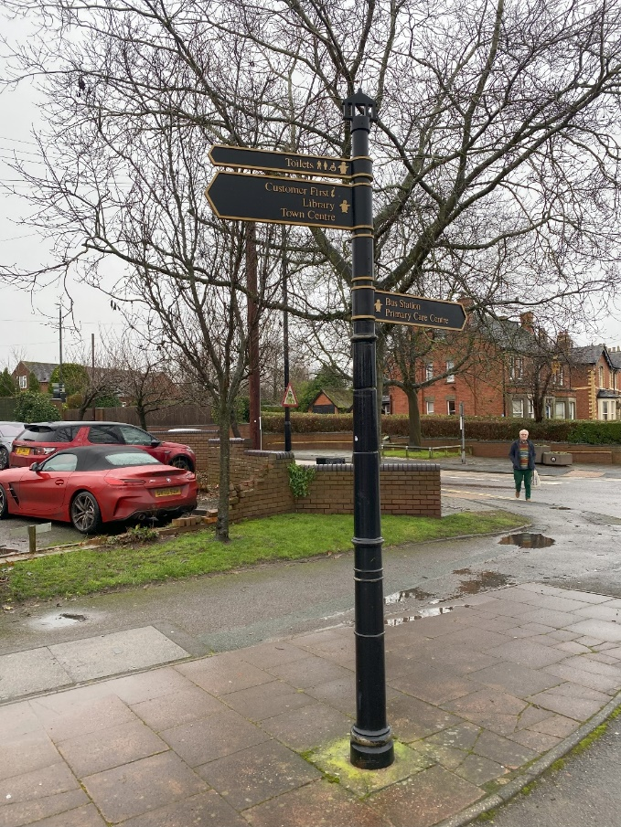
Current signage | Proposed Signage
Toilets | Toilets
Customer First  Library  Town Centre | Street Market (Wed)  Library  Town Centre
Sign broken off | Health Centre  Fire Station
Bus Station  Primary Care Centre | Bus Station

Arlon square
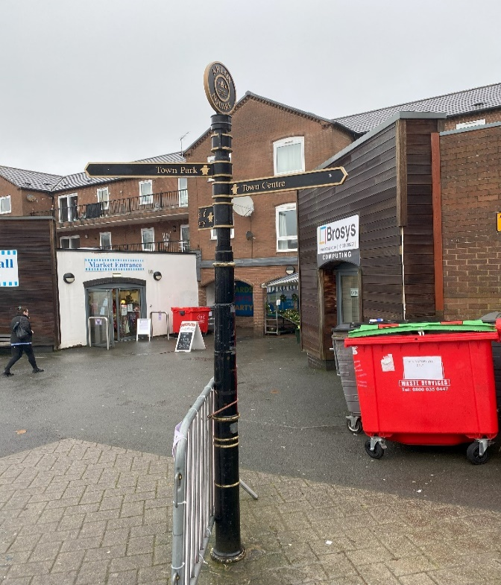
Current Signage | Proposed Signage
Sign broken off | Museum
Town Park | Town Park
Town Centre | Town Centre
Sign Broken off | Library  Bus Station

