Services and Facilities Committee Meeting | 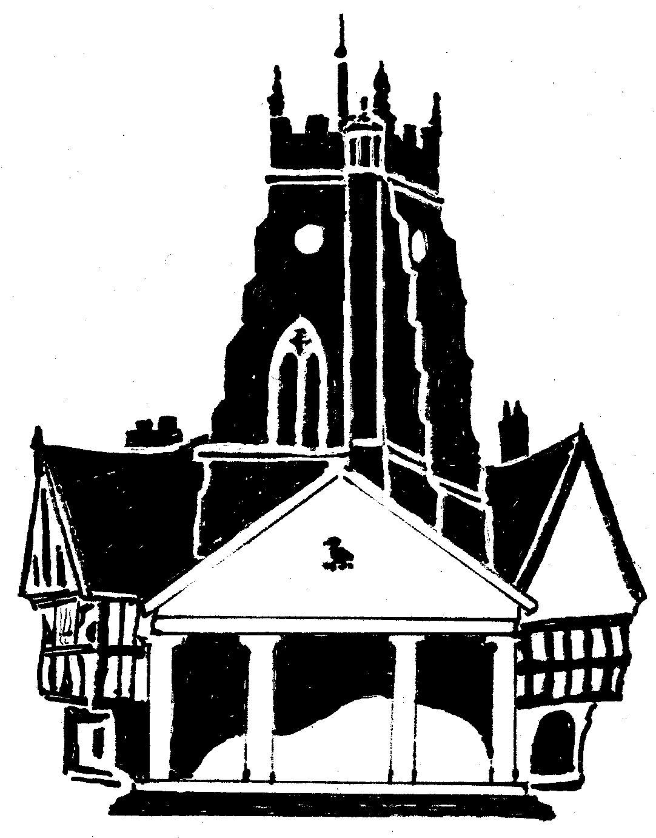  Market Drayton  Town Council
Agenda Item: 5.SF Festival of Lights

Date: 21 March 2024

Appendix : SF164

Background
For many years LSD has provided markets stalls for the Festival of Lights at a discounted price. As they will not be managing the town markets after the 31 March 2004 they will not have any stalls or workers in the area to continue this arrangement.
Five companies have been contacted to provide quotes. Three quotes have been received; only two of which are suitable.
Due to the increased stall hire costs there will be a shortfall in budget as set out below.
Using quote A as an example:
50 stalls hired at a cost of £74.74 would cost £3,734.
Charged out at the 2023 price of £30 would provide an income of £1,500
Resulting in a difference of £2,237. (£44.74 per stall)
An extra £1,500 has been included in the stall hire budget this financial year to cover rising stall hire costs which leaves a budget shortfall of £737. (assuming all stalls are hired out)
To consider
- the quotes for the supply of market stalls
ii. increasing the charge to stallholders to hire a stall. Currently £30 for general stalls and £35 for catering stalls.
iii. covering the budget shortfall from general reserves.
iv. holding the Festival of Lights on the 14 November 2024.
Stall Hire Quotes
Quote | Price | Additional Information
A | £74.74 per stall  (£3,734.00)  50 stalls, 3m x 3m with sides, backs, tables and lighting | Includes delivery and erected
B | £79.47 per stall  (£2,860.80)  36 stalls, 3m x 3m, with sides, backs, tables and lighting | Includes delivery and erected
C | £50.20 per stall  (£2,510)  50 stalls, 6ft x 3ft table stalls with no backs or sides and no lights | Self assembly. Delivered 1-2 days before the event by pallet delivery and collected the next working day

