Council Meeting | 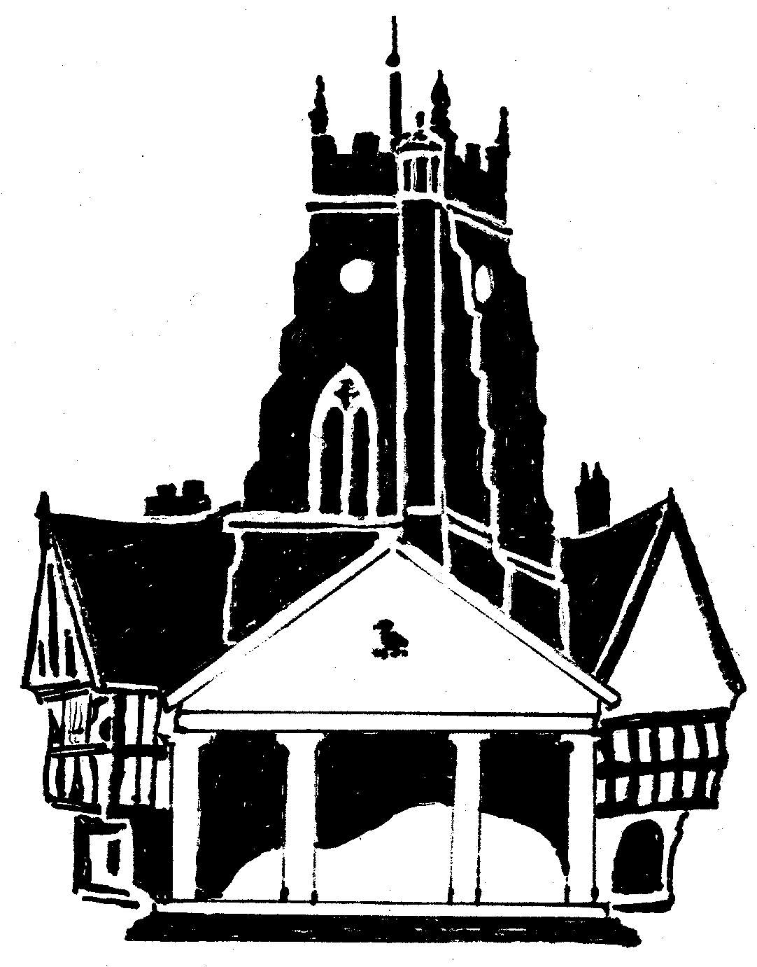  Market Drayton  Town Council
Agenda Item: 12C – Small Grants

Date: 18 March 2024

Appendix : CO172

Organisation | Requested Amount  £ | To Fund | Funded in 2023/24 | Documents  Received
Beacon Community Centre | £500 | Refurbishment of the kitchen and flooring at the Centre. | £0 | Constitution received
Drayton Civic Society | £500 | Towards roof repairs at the Museum. | £0 | Constitution received
Market Drayton Men Shed | £500 | To help with overhead costs i.e., electric. | £300 | Constitution received
Friends of Market Drayton Library | £500 | To purchase audio equipment for Library events | £0 | Constitution received
Classical Music Series/Festival Drayton Centre | £350 | To enable a collaboration between local artists and an internationally acclaimed musician. | £0 | Constitution received
Market Drayton Climate Action | £500 | Running Costs such as room hire at Mencap, speaker costs, domain name costs, produce paper leaflets and training. | £300 | Only Aims received

