Council Meeting | 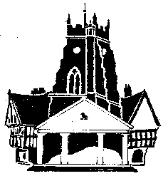  Market Drayton  Town Council
Agenda Item: 20.C Street Lights

Date: 9 May 2024

Appendix : CO11

The floods lights on High Street have not been working for a several months.
As High Street is in a conservation area Shropshire Council are proposing to install some replacement street lights at either end of the benches, see examples below.
The final design will come down to the limitations of the lantern at design stage as they will be required to light to a highway standard.
