Services and Facilities Committee Meeting | 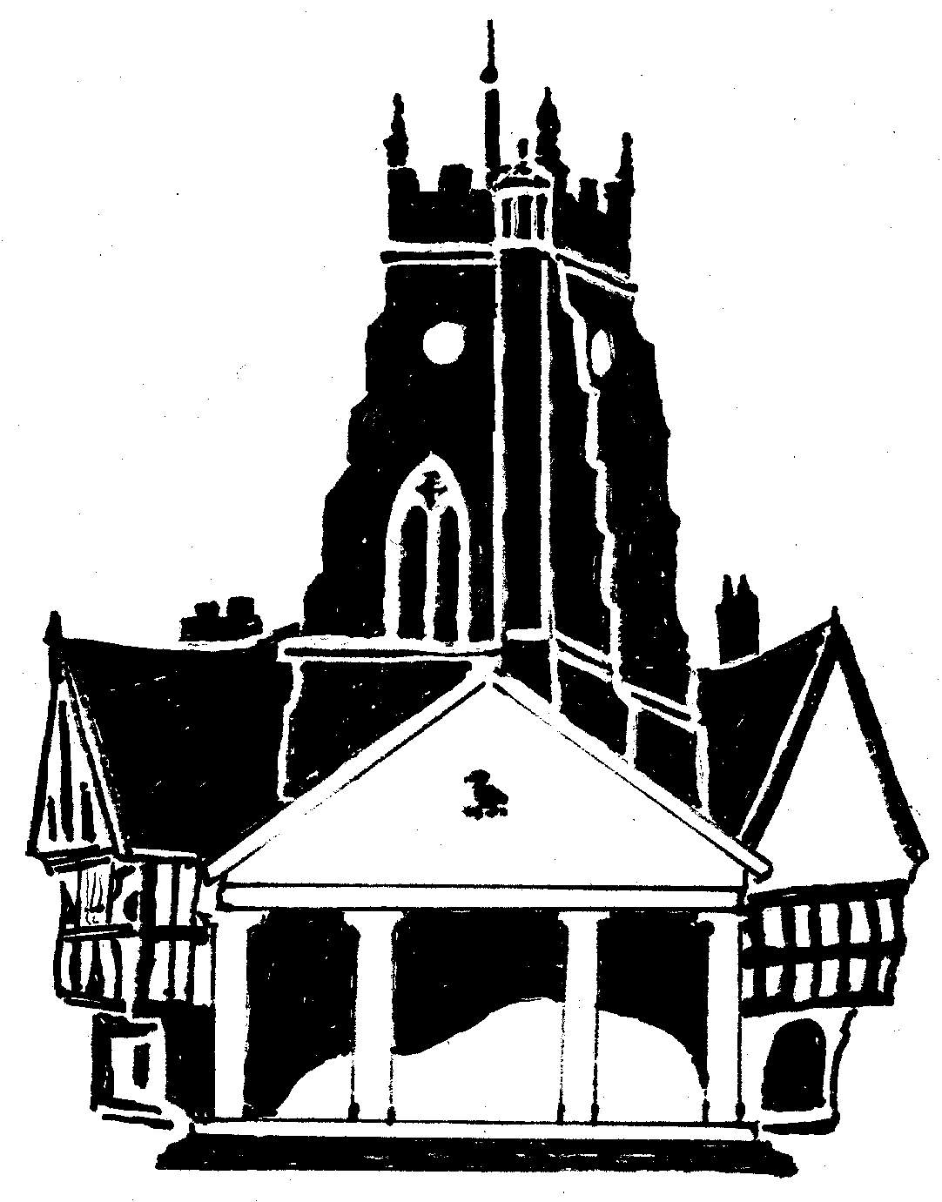  Market Drayton  Town Council
Agenda Item: Biodiversity Action Plan

Date: 23 May 2024

Appendix : SF015

To work towards achieving objectives 1 – 4 of the Biodiversity Policy Action Plan it is proposed the points set out in the attached document are implemented.
Recommendations
- To agree to install bat boxes and bird boxes; create a compost area for wildlife and leave an area un-mowed at the cemetery
- To agree to install bird boxes on a selection of recreation areas
- To agree to leave sections of Croft Way, Town Park, Grotto Road and Forest Road recreation areas un-mowed and scatter wild flower seeds/plant plugs to increase diversity of habitats and food sources.
- To install appropriate signage at all locations
- To promote actions on face book and website

Action Point 4. Suggested locations for un-mowed, wild flower areas:
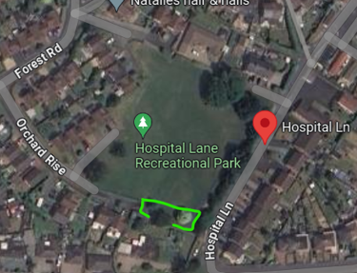 | 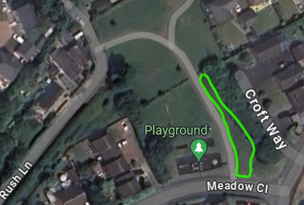
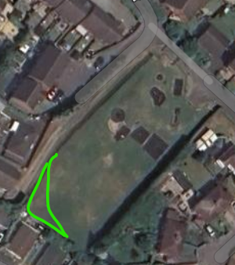  Grotto Road | 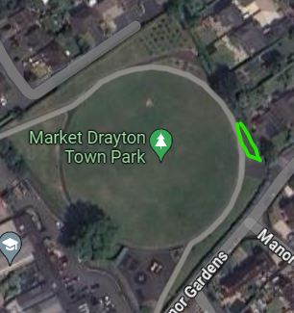

Action Points 1, 2, 3 & 4
Example of Signage
