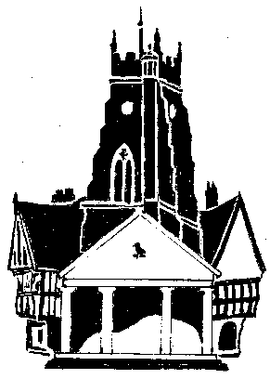
Market Drayton Town Council
Invitation to Quote
You are invited to quote for the work below which briefly breaks down into two phases and comprises of the production of building plans and a tender specification for the refurbishment of Towers Lawn toilets

Market Drayton Town Council are looking to refurbish Towers Lawn Toilets, Frogmore Road, Market Drayton, TF9 3AA.
The current building is split into Ladies and Gents toilets, both of which have communal areas, there is the addition of a separate disabled toilet.
The Town Council’s preferred option going forward is to redesign the toilet block to have four single use toilets and one DDA complaint toilet.
The Town Council are initially seeking costs to produce phases 1 & 2 of the work outlined below, the work will be split into two separate phases.

Phase one
To produce building plans for the current layout and the proposed layout of the toilet block. To include details of the drainage……the design stage.

Phase Two
To produce a full tender specification, including building specification and Building Regulations Specification for the toilet refurbishment which the Town Council will utilize to enter a separate tender process with a chosen contractor. It is expected the successful agent for this Phase Two process will manage & liaise with any potential contractors prior to the tendering of the work and liaise with the successful contractor during the works.

Once Council has approved the costs the successful company will be invited to discuss in detail the project and produce phase 1 ASAP.

