Services and Facilities Committee Meeting | 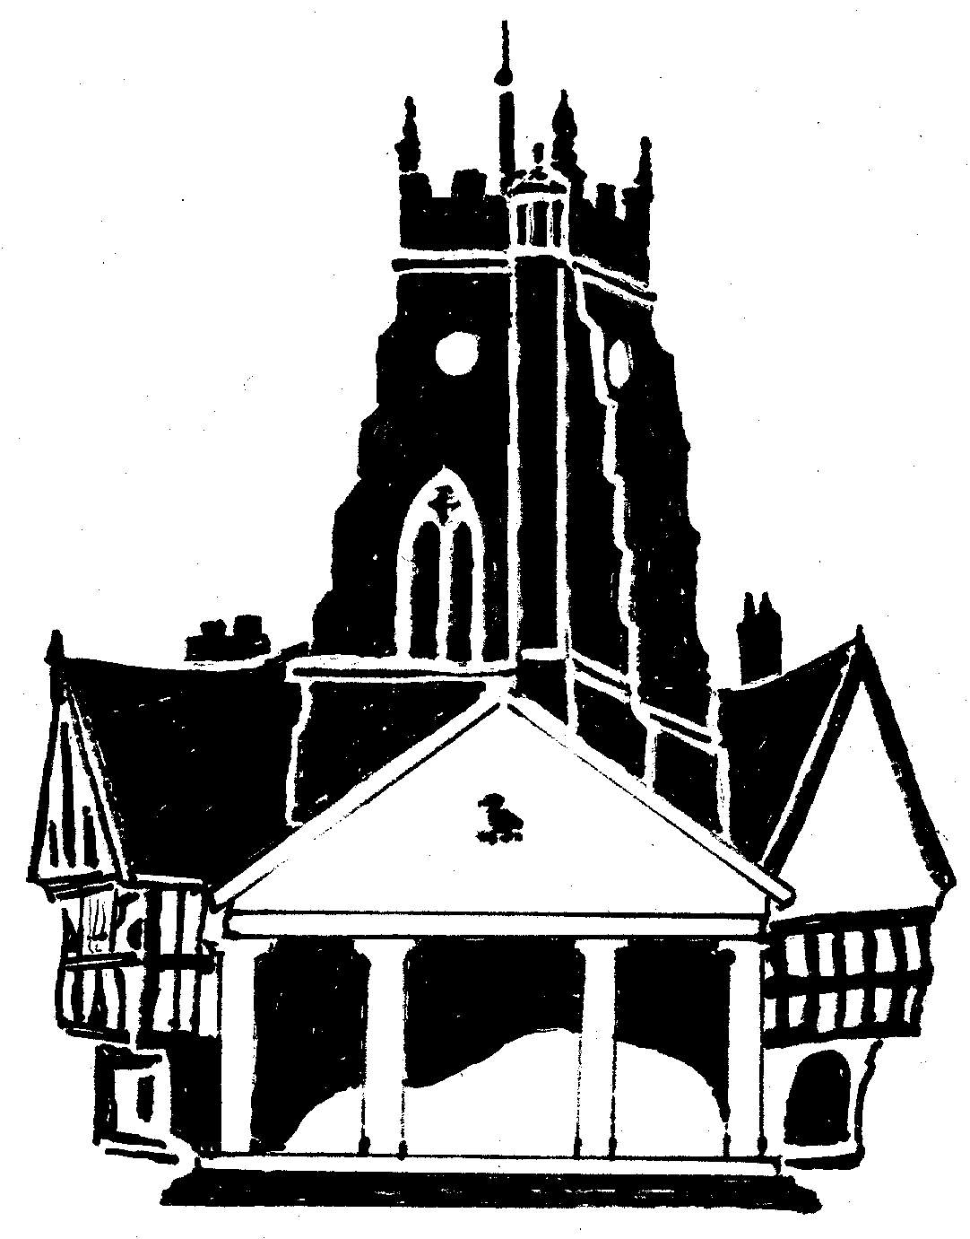  Market Drayton  Town Council
Agenda Item: Christmas Lights

Date: 25 July 2024

Appendix : SF049

Background
There is £5,000 in budget for new lights. The prices below have been obtained from the company who currently install and switch on the lights.
Quote
Further to our recent conversations, I am pleased to be able to submit our quotation for tree lighting in Marker Drayton.
As requested I have divided the quote into 3 key areas and also allowed for two possible design options for each.
I know all these areas have been illuminated at some point as well. So we do have some infrastructure but it will need updating, both at Queens St and the Bus Station. The Library can be fed from the existing decorations on the building.
Two design options –
1 -
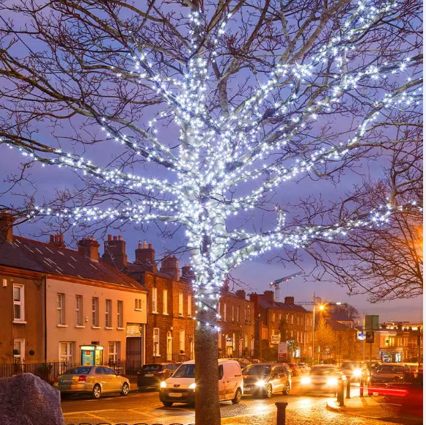
Using the traditional method of branch wrapping each tree, this is as described giving a loose fitting wrap to each key branch the trees, and allowing for a silhouette outline when illuminated. This is very popular because of how good it looks, however tree growth does need to be considered and I would suggest a reliable life span of approx 3 years for the display. We now use low voltage lights from branch wrapping as they are less sensitive to outside factors and therefore unlikely to trip or fail.

2 -
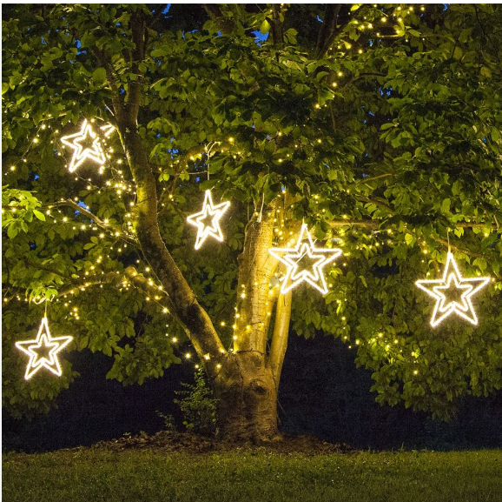
Another option to be considered is a harness that is fitted into each tree which again follows the main branches of the tree. Each harness has several outlets where miniature motifs can be suspended, such as stars or snowflakes or boas as used elsewhere in the display. The benefit of this is, is that the motifs are removed each season and therefore we would expect a longer life for them. However this form of display is not always as effective as the traditional wrapping.

Library
Option 1. To supply and install branch Wrap LED lighting to two mature trees (560m total) - 28 sets LED LV lighting - £1542.80 - installation £1150.00 - £2692.80 plus vat.
Option 2. To supply and install motif harness and motifs x 22 (11 each) to two mature trees - Harnesses and 22 motifs - £1830.00 - installation £900.00 - £2730.00 plus vat.
Queen St
Option 1. To supply and install branch Wrap LED lighting to mature tree (260m total) - 13 sets LED LV lighting - £716.30 - installation - £625.00 - £1341.30 plus vat
Option 2. To supply and install motif harness and motifs x 14 to mature tree - Harnesses and 14 motifs - £1120.00 - installation - £575.00 - £1695.00 plus vat.
To upgrade electrical infrastructure in existing lamp column - £325.00 -
Bus Station
Option 1. To supply and install branch Wrap LED lighting to mature tree (320m total) - 16 sets ED LV lighting - £881.60 - installation - £625.00 - £ 1506.60 plus vat.
Option 2. To supply and install motif harness and motifs x 18 to mature tree - Harnesses and 18 motifs - £1370.00 - installation - £725.00 - £ 2095.00 plus vat.
To upgrade electrical infrastructure in existing lamp column £325.00

Recommendation from the Chair
To accept the quote for design option 1 by the Library and Bus Station at a cost of £4524.40.

