Services and Facilities Committee Meeting | 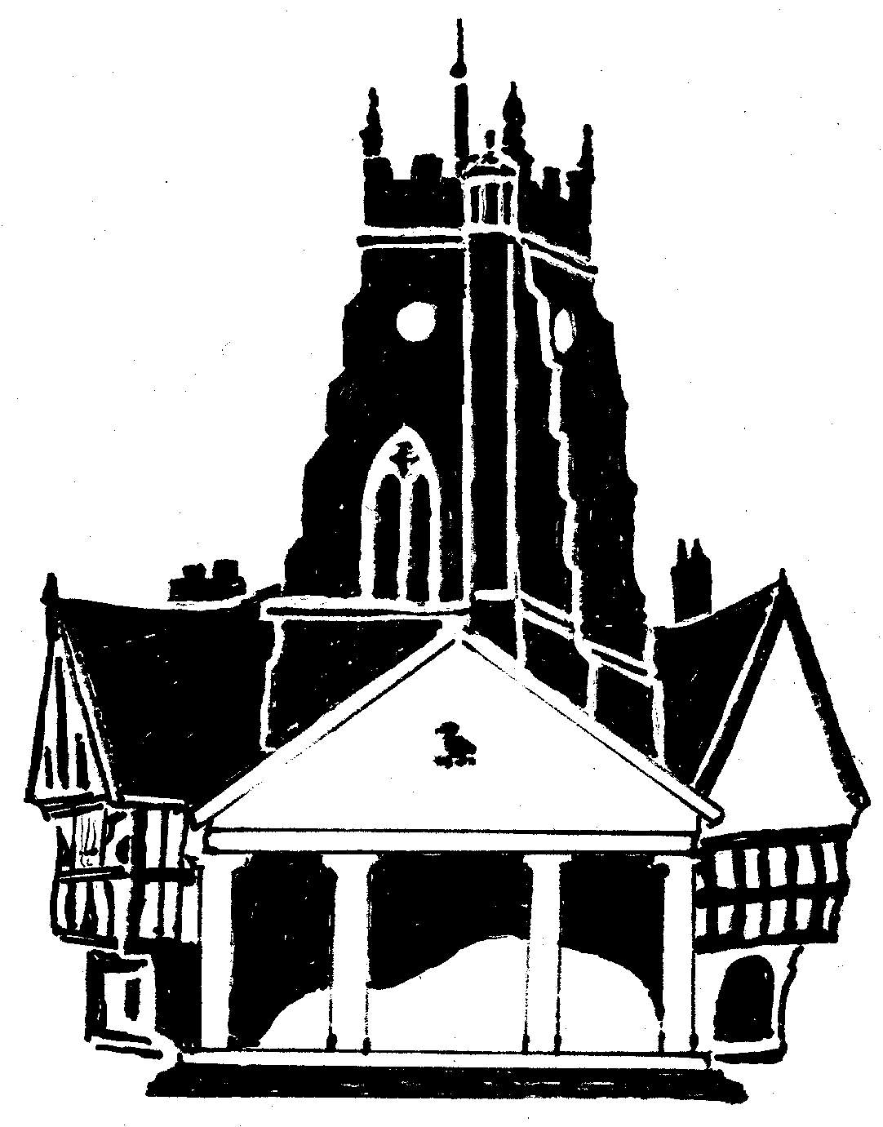  Market Drayton  Town Council
Agenda Item: Cemetery Chapel Windows

Date: 25 July 2024

Appendix : SF050

Background
The windows in the cemetery chapel have deteriorated over many years; it is believed that most of the windows still have the original glass in.
Three companies were approached to quote to refurbish the windows; two companies attended site visits and have quoted.
It has also been suggested that the windows should be carefully cleaned. This work is optional.

Quotes
Quote 1 |  | Quote 2
Porch (west) window | 1345.00 | Small Window Front | 1568.00
South Window (next to door) | 2980.00 | (Included below) | (Included below)
South Window | 2980.00 | Small Windows side x2 (inc. cleaning) | 1682.00
West Window | 3845.00 | Large Window Front | 4548.00
East Window | 3845.00 | Large Window Back | 4548.00
Scaffolding | Included | Scaffolding | 3900.00
Repairs/Cleaning | Not Included | Repairs/Cleaning windows inside and out | 595.00
 | £14,995 |  | £16,841

- Quote 1 declined to quote for cleaning
- Quote 2 includes for cleaning and additional individual glass pain onsite repairs

