Services and Facilities Committee Meeting |   Market Drayton  Town Council
Agenda Item: Rowen Road Allotments

Date: 25 July 2024

Appendix : SF051

Background
The allotments on Rowan Road have been broken into several times. Tools have been stolen and equipment and sheds have been damaged.
On the last occasion the site was broken into the fence was cut to gain access; temporary boards have been put up as a quick fix.
As you can see below there are areas of the fencing/hedge that are poor, which provide a good view of what is on the allotments.
Councillor Manton and the Clerk met with the Chair of the Allotment Society to discuss options to try and reduce the break-ins; it was agreed that fencing needs to be erected as a deterrent.
The Clerk and the Chair of the Allotment Society met with three different companies to discuss options.
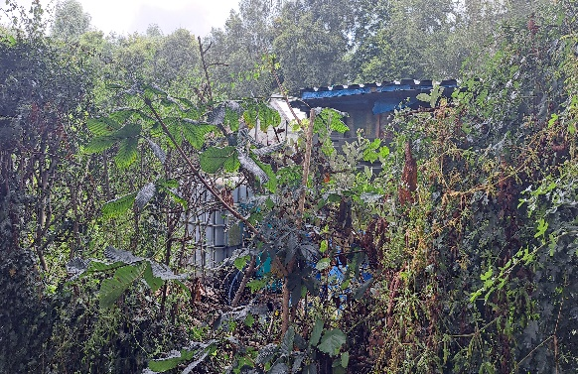 | 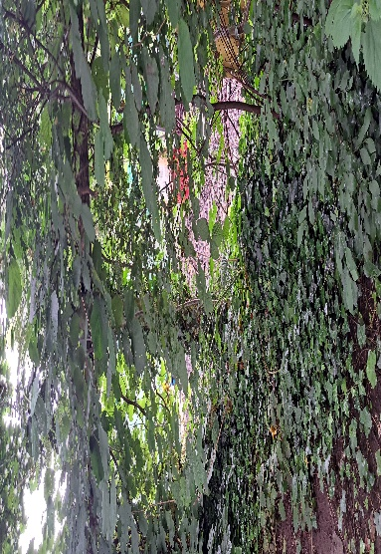
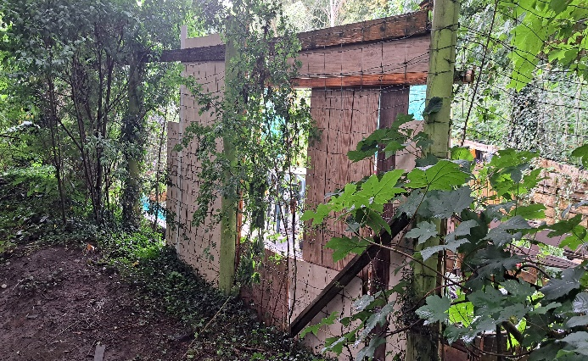 | 