[Home](https://midwestdisplays.co.uk/) › [Digital Display Screen Range | Advertising Displays](https://midwestdisplays.co.uk/collections/digital-display-screens) › Slimline Display Screens | 3yr warranty + free tech support + free mount

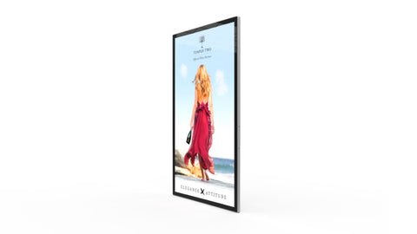

SLIMLINE DISPLAY SCREENS | 3YR WARRANTY + FREE TECH SUPPORT + FREE MOUNT

SKU AAD19

Top of Form

Usually ships in 3-5 working days

Regular price

**£355.00** £426.00 inc VAT

Sale price

Product Options

Screen Size19" Slimline Advertising Screen22" Slimline Advertising Screen32" Slimline Advertising Screen43" Slimline Advertising Screen50" Slimline Advertising Screen55" Slimline Advertising Screen

                                                                       19" Slimline Advertising Screen - £355.00 GBP                                                                                         22" Slimline Advertising Screen - £404.00 GBP                                                                                         32" Slimline Advertising Screen - £632.00 GBP                                                                                         43" Slimline Advertising Screen - £860.00 GBP                                                                                         50" Slimline Advertising Screen - £1,013.00 GBP                                                                                         55" Slimline Advertising Screen - £1,350.00 GBP

Quantity

You might also like these related products

* [Description](https://midwestdisplays.co.uk/collections/digital-display-screens/products/advertising-displays#tabs-2)
* [Features & Downloads](https://midwestdisplays.co.uk/collections/digital-display-screens/products/advertising-displays#tabs-3)

Our slimmest & sleekest advertising displays – EVER

With their stylish tablet looks, smart & sturdy aluminium surround these stunning advertising displays will look good in any location. Now with a 70% slimmer border and over 30% lighter, their enhanced aluminium surround is made of diamond-cut 6-series aluminium alloy and now features a unique concave indent profile, adding to the premium quality as well as making these displays truly distinct.

As well as style there is substance to these advertising displays. With a commercial grade 450 cd/m2 IPS panel, integrated Android media player and speakers this [digital screen](https://midwestdisplays.co.uk/collections/digital-display-screens)will deliver high impact digital marketing designed to build brand, boost sales and say ‘bye ‘bye to the competition.

High impact advertising displays driving your success

With the ease of Plug N Play you’ll soon be uploading and updating dynamic content your customers will ❤️

Or use one of the many integrated input options. For a small fee you can [upgrade to a CMS Network](https://midwestdisplays.co.uk/products/network-cms)that gives instant access to loads of marketing & management tools such as design templates, remote uploading and user management – so the whole team can contribute to your marketing success.

Our slimmest ever screen, Our biggest ever bundle

We offer our advertising screens at the best prices online - but there are also loads more reasons to buy from Mid West Displays including

* **FREE** wall mount. The screen can be used portrait or landscape.
* **FREE** scheduling software – updating is easy
* **FREE** 3 yr warranty
* **FREE** lifetime telephone support
* **FREE** UK mainland delivery

Our fully trained team are here to help - from your initial enquiry to after sales care. We can even arrange installation of your screen if required.

These stunning screens are perfect for building brand, boosting sales and building customer loyalty & are ideal for

* shops, malls and other retail locations
* hotels, Food-to-Go and QSR restaurants
* hair and beauty salons
* gyms, health clubs and leisure centres
* reception areas and waiting rooms

Our fully trained team is happy to answer any questions. Call them today on 01743 465531 or [email the team](mailto:sales@midwestdisplays.co.uk)