Council Meeting
17th October 2024
Appendix C092

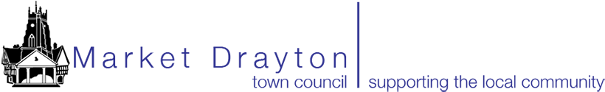
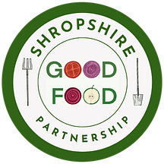

Request for Market Drayton Town Council to Support a Proposed Three-Year Project to Enable More Young People to Eat Healthy Food
Scope of National Lottery Reaching Communities Bid
The Shropshire Good Food Partnership works to create a better food system in our county and we are through the first stage of a National Lottery Reaching Communities bid to enable more young people in Shropshire to eat healthy food. There is mounting evidence that young people are experiencing ill health due to poor diet and that campaigns such as “5-a-day” have had little traction. A key part of this 3-year project will be to support 2 communities to act as pilots for being “Good Food” communities where young people are empowered to make the journey to healthier eating.
We seek Council support for Market Drayton to be one of these pilot communities.
What would the project involve?
This work will be shaped and led by Market Drayton’s community, supported by Shropshire Good Food Partnership. Community representatives would come together over a series of facilitated conversations to
- understand the barriers to healthy eating for young people in Market Drayton
- identify the opportunities to build on the resources you already have
- To select a project to collaborate together to make it easier for young people to eat healthy food and to build a culture where healthy food is the norm.
The project might be small or large. It might focus on overcoming stigma in asking for help, setting up more regular community meals for families or cooking and nutrition training, depending on the community’s view. The Partnership will provide support as needed in facilitation, overcoming blocks and seedcorn funding to test the idea, with help to seek more substantial funding if needed.
Community representatives including Market Drayton Town Council would be involved along with The Zone, Food Bank, GPs and local schools. Young people would be central to shaping the work through Market Drayton Youth Club and schools.
What would be asked of Market Drayton Town Council?
If the bid is successful, the project would run from early 2025 for 3 years. The Partnership would ask for support from the Council in connecting us with community representatives, loan of meeting room space, participation of a Council representative at foundational meetings, key decision points and reviews (approx. 4 meetings per year, but more frequent at the start) to guide the project and make sure that it is linked to what is already happening.
We would be grateful for confirmation of your agreement to be a pilot community, if the bid is successful.
Please contact Katy Anderson, Co-Director of Shropshire Good Food Partnership for more information: katy@shropshiregoodfood.org
SHROPSHIRE GOOD FOOD PARTNERSHIP CIC. Company number: 13773694

