Community and Governance Committee Meeting | 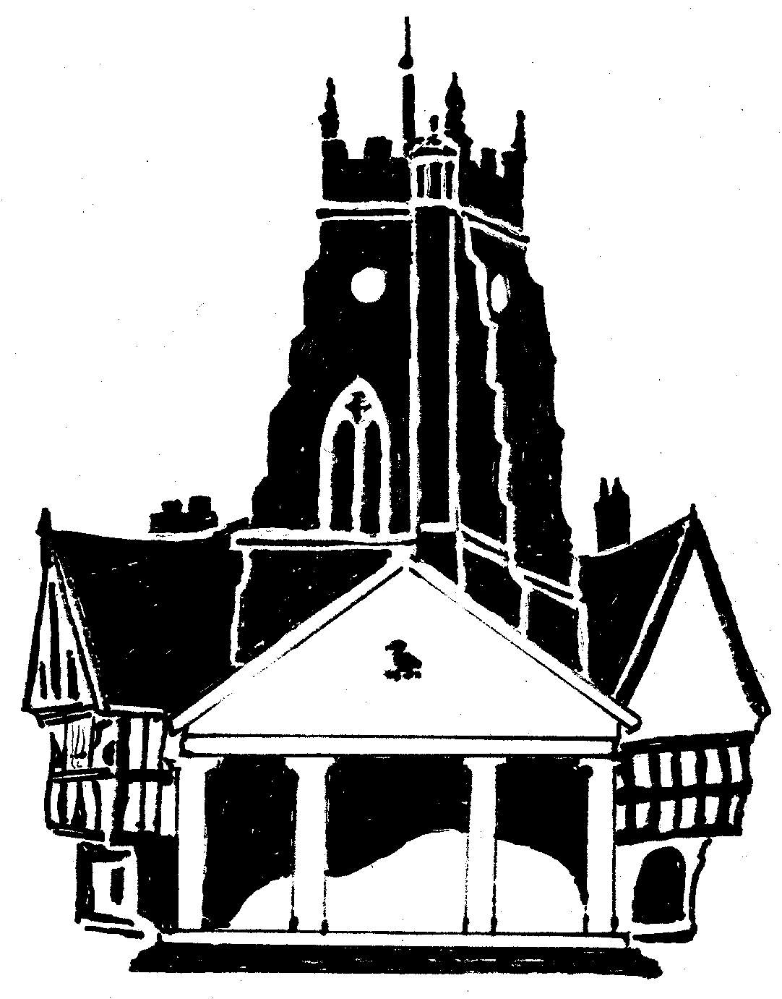  Market Drayton  Town Council
Agenda Item: Budget 2025/26

Date: 14 November 2024

Appendix : CG108

Cost Centre 301 | Description | Budget 2024/5 | Proposed Budget 2025/26
4017 | Police Panel | 1,500 | 0
4322 | Community Support and Events | 5,000 | 5,000
4323 | Community & Governance | 5,000 | 5,000
4326 | Citizens Advice Bureau | 6,000 | 5,000 | In line with funding provided last year
4968 | Public Transport | 6,000 | 6,500 | To continue to subsidise the Saturday Town Bus Service and/or support other local transport initiatives.
4969 | Communications and Promotion | 4,000 | 70,000 | To continue to fund Visit Shropshire, pay for consultant support and implement town action plan initiatives (60k to be allocated from reserves)
Total |  | 27,500 | 91,500 | £64,000 increase (60,000 to be taken from reserves)

