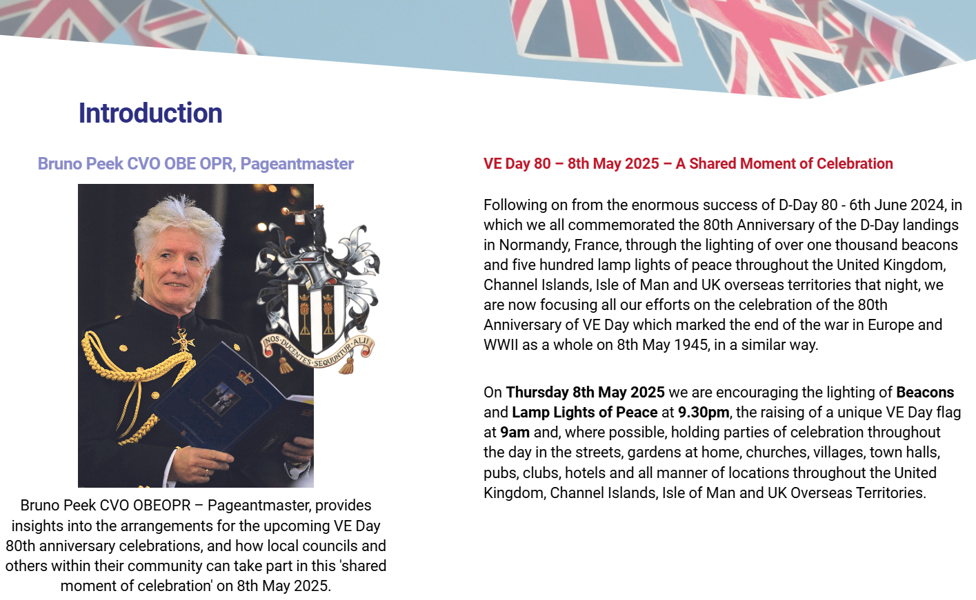
Community and Governance Meeting
14 November 2024
Appendix CG112
More information can be found at: https://www.veday80.org.uk/?utm_source=MEMBERS&utm_campaign=f563994e1f-EMAIL_CAMPAIGN_2018_06_08_03_15_COPY_01&utm_medium=email&utm_term=0_206970988f-f563994e1f-323644441&mc_cid=f563994e1f&mc_eid=1a5fc8b509

