Services and Facilities Committee Meeting | 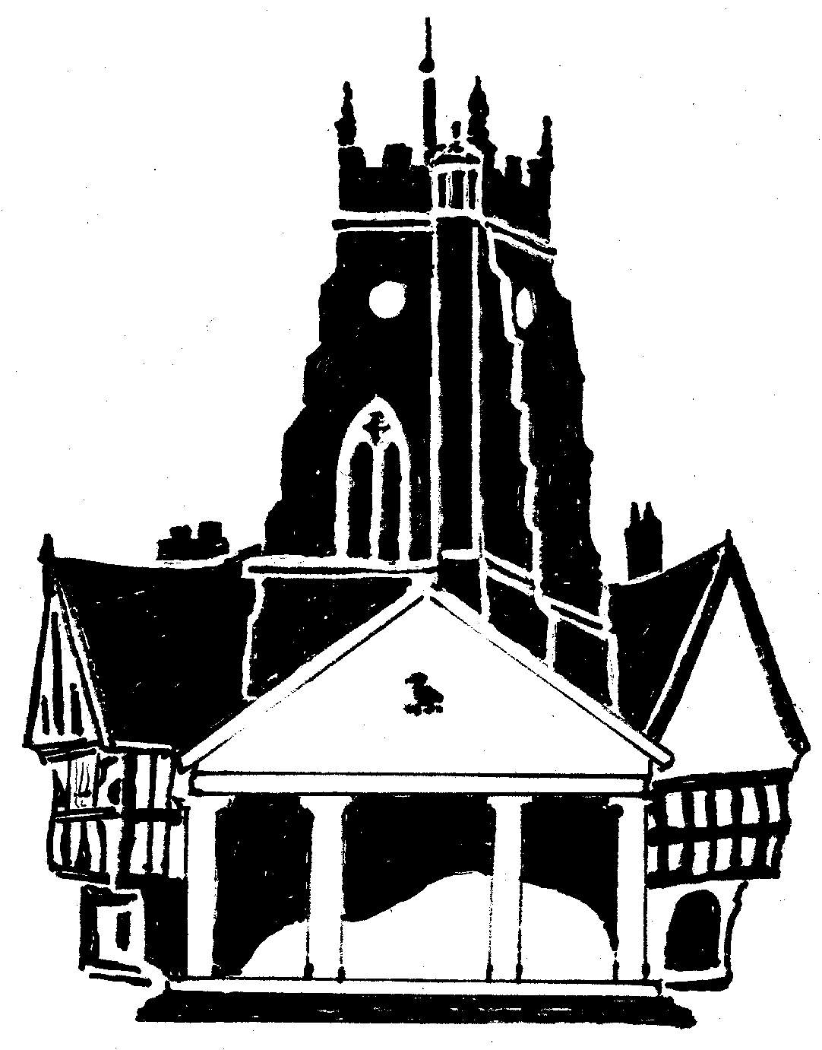  Market Drayton  Town Council
Agenda Item: 5.SF Youth Club

Date: 12 December 2024

Appendix : SF117

Background
The Town Council currently pay for weekly junior and senior youth club sessions which are run by SYA at the Phoenix Centre and a Wednesday evening.
The junior session (10-12 yrs) is held from 5.15pm to 6.45pm and is very well attended. The senior session (13 yrs and over) is from 7.00pm to 8.30pm, numbers to this session are lower.
The costs are for:
- 2 x 1.5 hour session (plus 0.5 hour for setting up and cleaning up)
- Term time only (39 weeks)
- 3 staff + management support

The current costs are:
Session | Ex VAT | Description | Inc room hire
Junior and Senior back to back | £18,800.00 | Without trips | £20,360.00

The costs for 2025/26 are:
The below table sets out the cost to provide one and two youth club sessions. There is also the option to pay for trips. The cost to hire the Phoenix Centre is currently £10 per hour; an increase in charges has not been discussed by the committee.
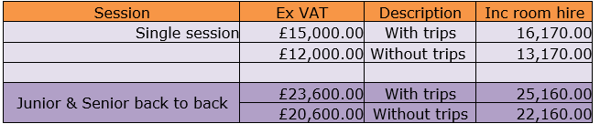

To consider:
- Continuing to pay for youth club provision

