Services and Facilities Committee Meeting | 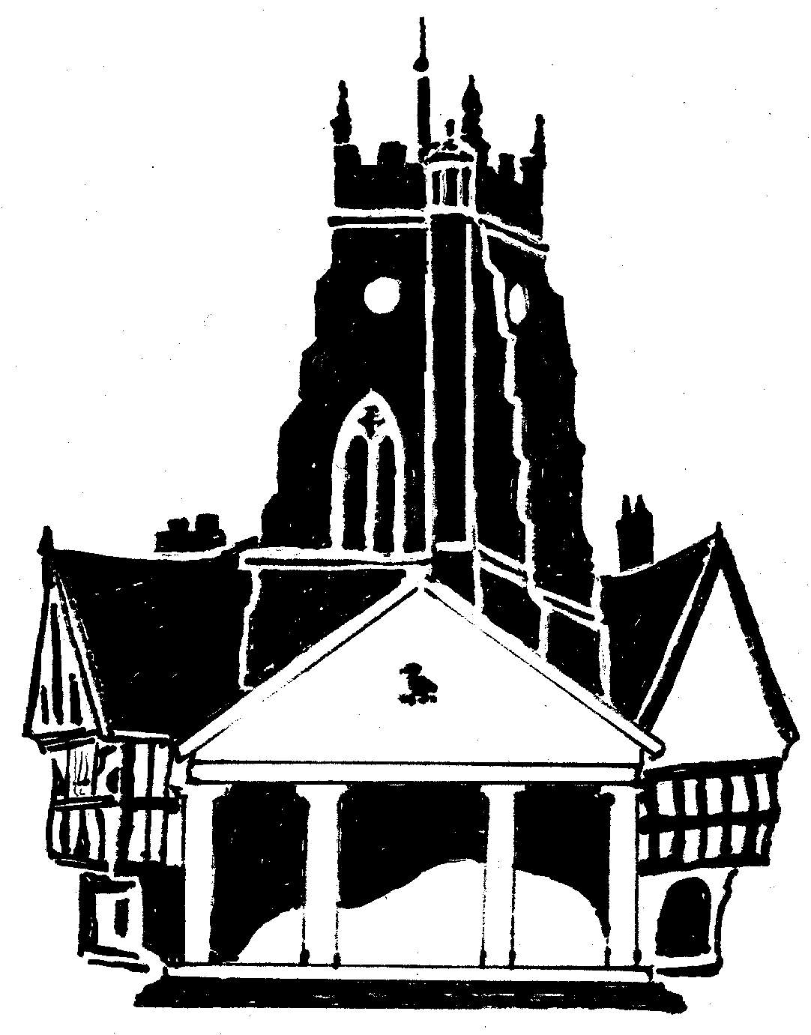  Market Drayton  Town Council
Agenda Item: 6.SF Floral Displays

Date: 12 December 2024

Appendix : SF118

Background
The Town Council put up 114 handing baskets, 29 mangers and 35 pole top displays each year.
37 hanging baskets are put up outside local business, 3 poletops, 2 mangers and 3 baskets are put up at the Doctors surgery.
The remainder are put up at various locations around the town.
The local businesses have previously been charged a £20 watering fee for the hanging baskets.
The doctor’s surgery pay in full for their floral displays plus a £20 watering fee.

Quotes
6 local companies were contacted regarding the opportunity to quote for the provision and installation of the floral displays.
1 company responded to say they were unable to quote
2 companies expressed an interest in quoting
1 company quoted

To Consider:
- the quote for the provision and installation of the floral displays in the town.
- increasing the watering fee charged to local businesses who are provided with a hanging basket outside their business premises by the Town Council.

