|  |  |
| --- | --- |
| **Services and Facilities Committee Meeting** | A black and white drawing of a building with a tower  Description automatically generated with low confidence  Market Drayton  Town Council |
| **Agenda Item: 7.SF Hampton Drive Play Area** |
| **Date: 12 December 2024** |
| **Appendix : SF119** |

**Residents Request**

Good afternoon

I have discussed the possibility of having some trees planted on the green surrounding the children’s play area on Stuart Way and the residents are very much in favour.

We have researched suitable varieties and taken advice from several nurseries and a local tree surgeon and propose the following species:

1 x Sorbus (Rowan, Mountain Ash) – position 3 on plan

1 x Carpinus (Hornbeam) – position 4 on plan

1 x Betula Jacquemontii (White stem birch) – position 2 on plan

1 x Prunus (Shirotae flowering cherry) – position 1 on plan

We believe having different species improves biodiversity and enhances the overall appearance of the area. The trees will eventually provide some shade and help with occasional flooding of the area. These particular trees are relatively low cost (between £45 and £60 each) but will enhance the area for the whole community.

Whilst I am hopeful the council will be able to fund the trees, I realise this may not be possible. If this is the case, then perhaps a contribution could be made, and I will endeavour to raise the rest from residents?

I have attached a plan of where we wish the trees to be planted, ensuring that the trees at positions 3 and 4 are planted suitably far enough back from the road so as not to obstruct the view when pulling out of Stuart Way. There is also a photograph taken from my property.

I have been in communication with Hassall & Sons Tree Care (resident on the estate), who are more than happy to provide maintenance as and when required.

I look forward to hearing from you soon.

If you have any further questions, please do not hesitate to contact me.

Thank you for your time.

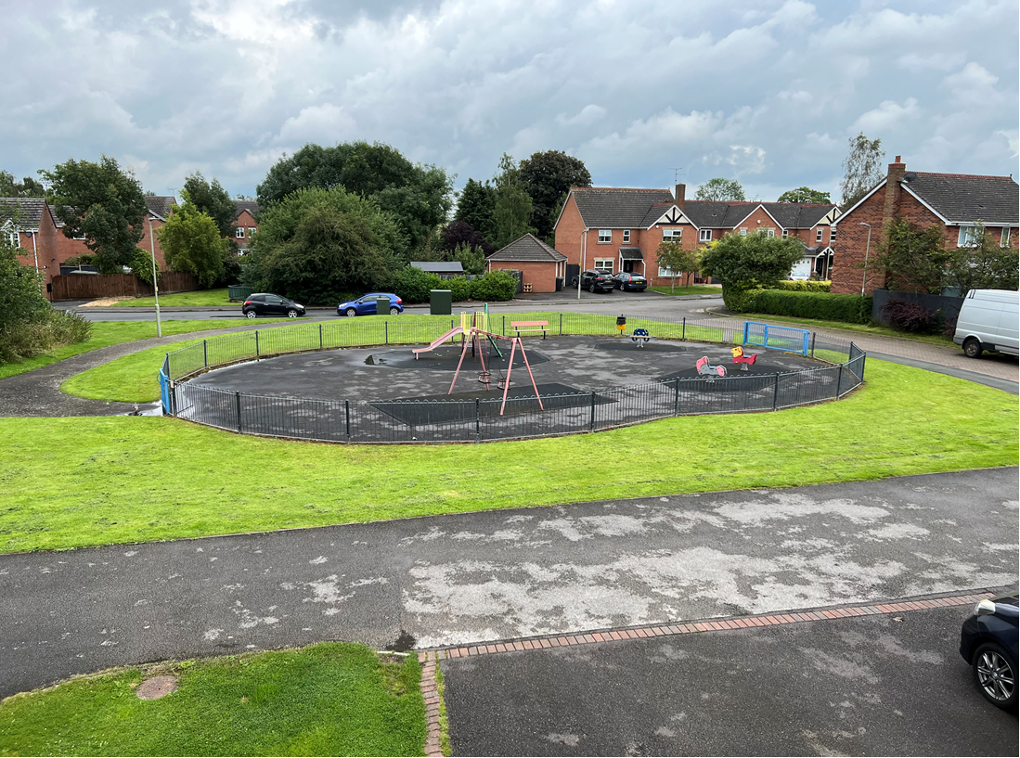

**To Consider:**

To consider a request from a local resident to plant some trees on the grassed area around Hampon Drive play area.