Services and Facilities Committee Meeting | 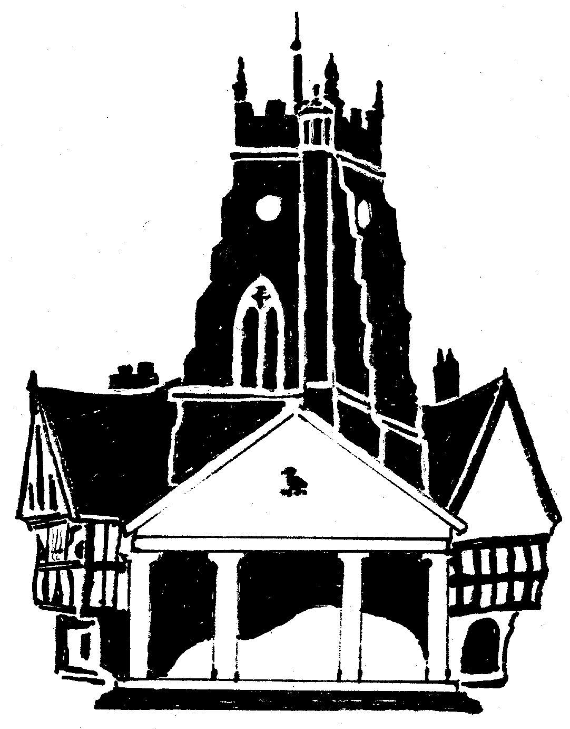  Market Drayton  Town Council
Agenda Item: Memorial Stones

Date: 6 March 2025

Appendix : SF166

An Inspection of the memorial stones at the Cemetery is underway. So far 20 memorials have been identified as being unstable; the burial dates range from 1905 to the late 1990’s.
‘A dangerous or unstable memorial is defined as one that will move and continue to fall to the ground with the exertion of a force of 25kg or less’.
The unstable memorials have been staked and notices put on asking relatives to contact the office.
As the Burial Authority we must:
Notify Grave Owners.
When memorials are found to be unsafe, consideration of the practicalities of this process must be considered. This will mean writing to the last known address of the owners of memorials less than 30 years old, as set out in The Local Authorities' Cemeteries Order 1977 schedule 3.
Making Safe
As the burial authority we must make any memorial found to be unsafe PERMANENTLY safe within 18 months.
Where owners cannot be traced the burial authority has to make a decision on how to deal with the memorial.
Options for making safe
There are three options available:
- Repair
- Sink memorials into the ground
- Lay flat
Updates
A recommendation report to be brought to a future meeting.

