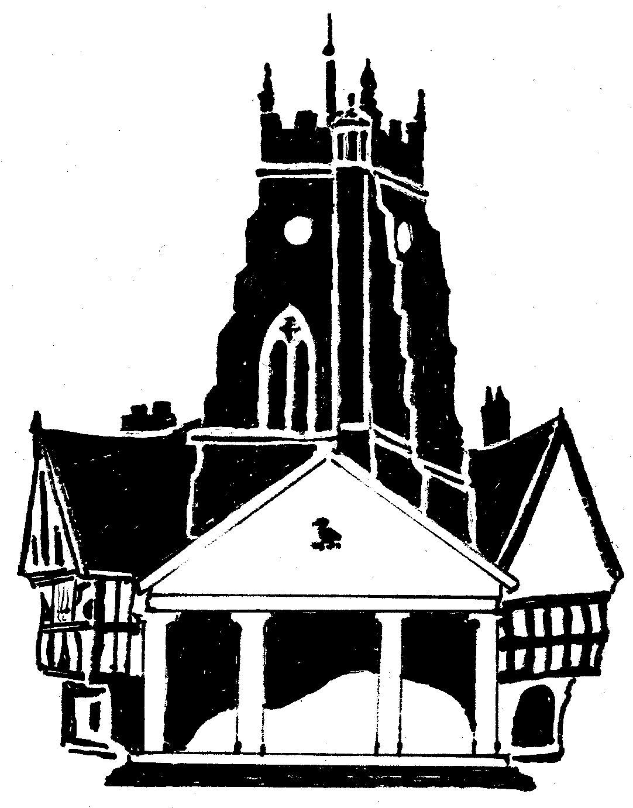
Market Drayton Town Council

CO-OPTION OF A COUNCILLOR FOR
THE NORTH WARD
MARKET DRAYTON TOWN COUNCIL
Public Notice is Hereby Given

At the close of nominations on 3 April 2025, Market Drayton Town Council
has a vacancy for 1 Councillor in the North Ward which can now be filled
by co-option.

Applications are now being sought from any suitably qualified
person who wishes to stand for co-option onto the Council.

Written applications should be made to the Clerk of the Council
by no later than Wednesday 4 June 2025 and these will be considered at
the Town Council Meeting to be held on Thursday 12 June 2025.

For an application pack, please contact:
Town Clerk
Market Drayton Town Council
18 Frogmore Road
Market Drayton
TF9 3AX
Tel: 01630 653364
Email: townclerk@marketdrayton.gov.uk

6 May 2025

Eligibility Criteria to be a Councillor

To be eligible to stand as a councillor you must be qualified by virtue of being a British or Commonwealth Citizen, citizen of the Republic of Ireland or European Union citizen, who has attained the age of 18 years and is:

(a) registered as a local government elector for the parish; and/or who has (b) during the whole of the twelve months preceding the appointment occupied as owner or tenant land or other premises in the parish; and/or his/her
(c) principal or only place of work during those twelve months has been in the parish; and/or has
(d) during those twelve months resided in the parish or within 4.8 kilometres of it; and is not disqualified from holding office by reason of any disqualification set out in Section 80 of the Local Government Act 1972.

