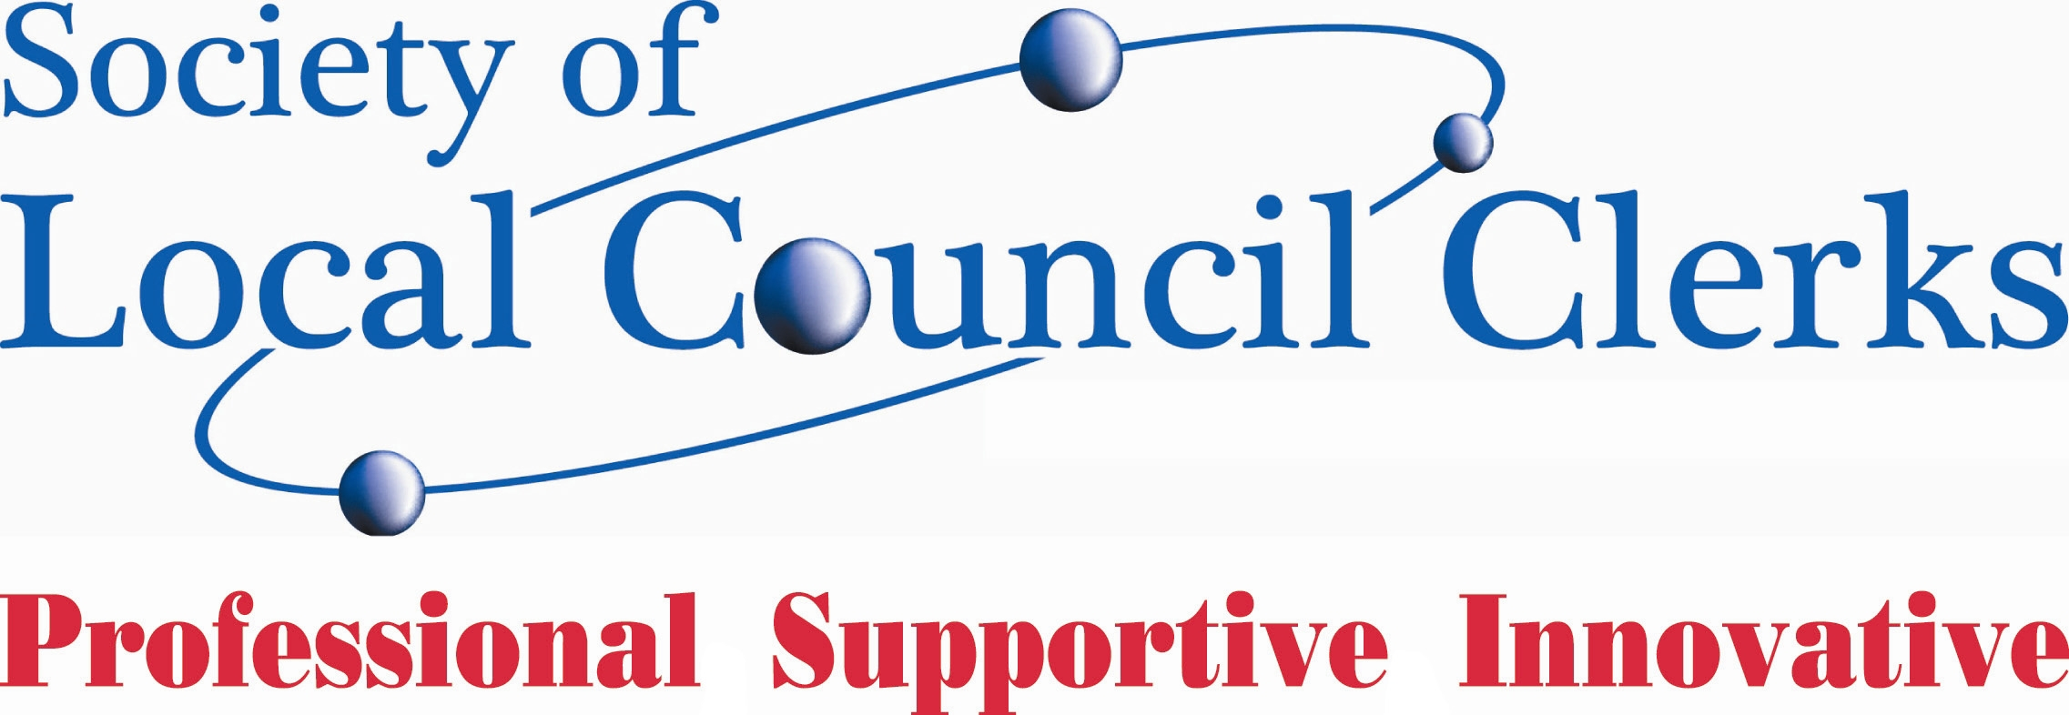
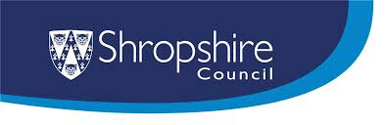
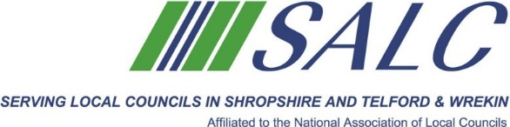

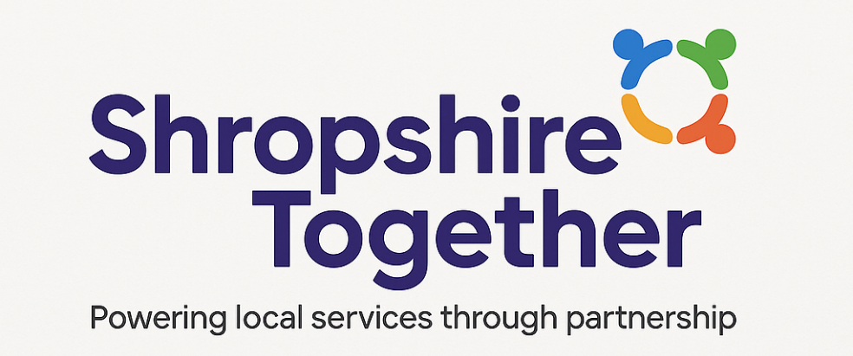

Shropshire Together Conference

Friday 25th July 2025 – 9.00am – 3.30pm
Shrewsbury Town Football Club, Oteley Road, Shrewsbury

To help shape this new landscape together, SALC is hosting the Shropshire Together Conference – Powering Local Service Through Partnership. This event will be open to Councillors and Clerks to attend and will provide a platform to come together, get informed, and start building the future collaboratively.

🎯 Conference Outcomes:
- Clearer understanding of the opportunities and expectations
- Stronger links and collaboration between local councils
- A roadmap towards a formal Partnership Agreement
- Foundation for pilot initiatives and devolved models of service delivery

Cost - £21 per head

Programme
9.00am | Coffee & Registration
9.30am | Why Bring the County Together  Chris Mellings – Chief Officer gives his thoughts on the valuable role that Parish & Town Councils make in Shropshire and how they and the Shropshire Association of Local Councils working together can play in shaping the future of local government in Shropshire
10.15am | The National Picture  Justin Griggs -NALC’s Head of Policy gives a flavour of the devolution picture nationally and how it impacts on Parish Councils and why Shropshire Parish & Town Councils coming together now is critical
11.00am | Tea Break
11.15am | The Financial Reality  Councillor Alex Wagner – Deputy Leader of Shropshire Council details the financial challenges that the new administration faces and why it was important for him to reach out to all Parish & Town Councils to engage in more meaningful partnerships going forward
12.00pm | Learning From Others  David Mears – Town Clerk of Bridgwater tells the Somerset experience of service devolution to Parish & Town Councils and looks at how it has inspired the first tier of local government to become active leaders in their communities
12.30pm | Lunch
1.00pm | What does it mean for Clerks  Helen Ball – Town Clerk of Shrewsbury and Vice-Chairman of the Society of Local Council Clerks looks at the Clerks perspective. Having been a clerk to a small, medium and large parish council over her 28 year career in the local council sector she looks at how working together we can meet the challenges and create long term beneficial opportunities to shape local government
1.30pm | What does it mean for Councillors  Councillor Dan Thomas (Mayor of Much Wenlock) – looks at the councillors’ perspective. How can the elected members, the closest to local people help to shape a new future and engage with residents
2.00pm | Developing the Shropshire Together Partnership Agreement  Helen Ball & Clare Turner – Town Clerk & Deputy Town Clerk of Shrewsbury Town Council - will facilitate an interactive workshop looking at developing a bottom up partnership agreement between Parish & Town Councils, Shropshire Council, Shropshire Association of Local Councils and the Shropshire Branch of the Society of Local Council Clerks to create a blueprint for a stronger and more resilient local government for Shropshire
3.00pm | Reflection of the Day with the Chairman of the Shropshire Association of Local Councils  Councillor Rax Wickson – Chairman of the Shropshire Association of Local Councils & Councillor Heather Kidd – Leader of Shropshire Council give their reflections on Shropshire Together – Powering Services Through Partnership

