Council Meeting | 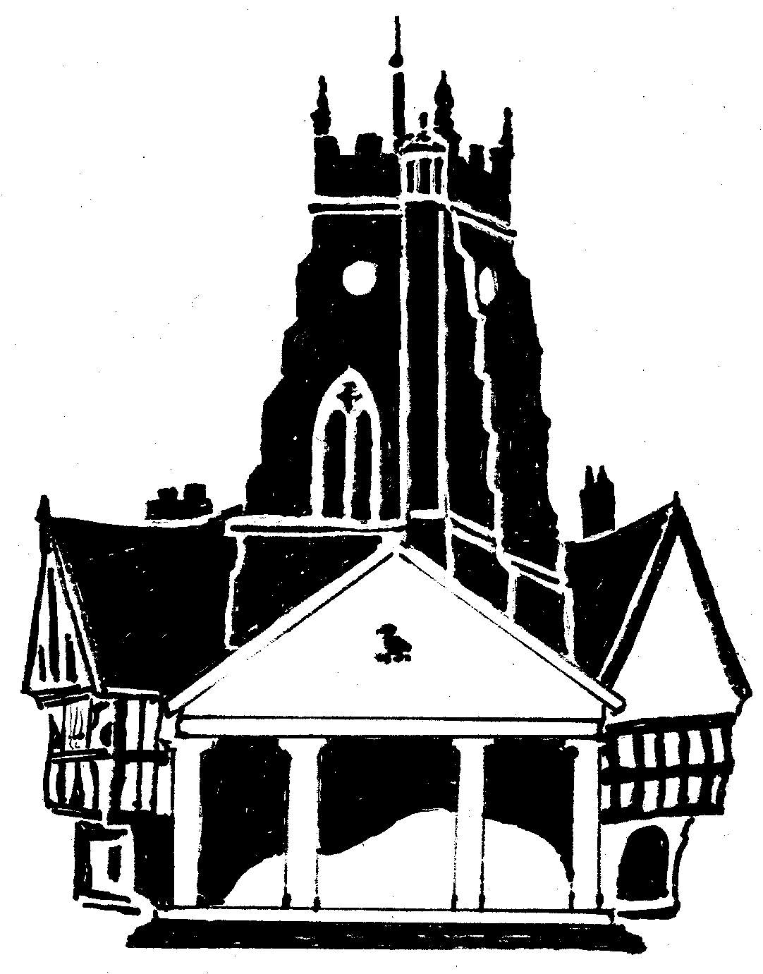  Market Drayton  Town Council
Agenda Item: Play Area Maintenance

Date: 14 August 2025

Appendix : C067

BUDGET SPENT TO DATE
Opening budget |  | £20,000
Repairs to wet pour on Town Park and Westlands (carried out due to H&S concern) | 3,500 | 16,500
Repairs to the Basket Swing on Bungtinsdale | 2449.00 | 14,051.00
Repairs to wet pour at Croft Way (caused by vandalism, H&S concern) | 3,596.35 | 10,454.65
Repairs to Slide unit on Longlands (H&S concern) | 855.00 | 9599.65
Budget spent to date | £9579.65
Proposed expenditure as listed below

Longlands  Climb Unit - Supply and fit three new timber pieces as discussed (include manufacturing on site) | 620.00 | 8979.65
Dalelands  Runway, - adjust Stops | 100.00 | 8879.65
Westlands  Gates - excavate 2 existing gates and supply and install 2 new Pro Safe Gates | 3,700 | 5179.65
Buntingsdale  Gates - to road new mechanism and adjust gate to play area (£490.00)  Runway - adjust seat 350 ground clearance with a load of 78 kilos (£50) | 570.00 | 4609.65
Budget remaining |  | £4609.65

OPTIONS FOR WORK TO BE UNDERTAKEN
Longlands
The slide unit had various rotten sections of wood which resulted in the fireman’s pole and bounce bridge being removed to make the unit safe for the short term, as shown below:
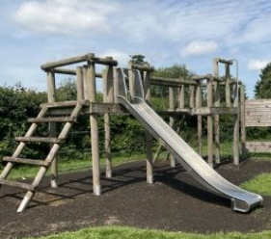 | 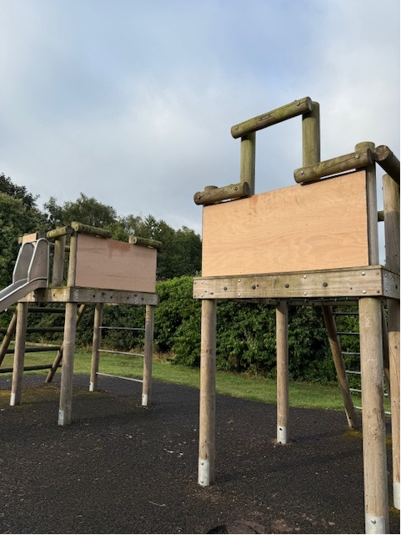

There are other sections of wood which are starting to rot and will need replacing over the next few years; the working group considers the unit uneconomic to repair.
The working group discussed the following two options.
Option 1.  Remove all items from site including Skip.  Cut off below ground level.  Remove all Rubber Surfacing (separate Skip due to rubber surcharge)  Supply and Lay topsoil and Seed over | £3730.00
Option 2.  Remove all items, cut off below ground level and fill the holes with wet pour. | £4230.00

A recommendation is not being made as to whether to replace the slide unit at this time. The working group recommends that, when budget is available, the young people are consulted as to what they would like installing.
Town Park
The recent Rospa inspection has rated the two rockers as a 12-medium risk.
The working group discussed the following two options:
Option 1. Replacing the rockers like for like.
Option 2. Replacing the rockers with a see saw.
The recommendation from the working group is Option 2. Once a decision has been made regarding which option to progress three quotes will be obtained. Funding to be from earmarked reserves.

FUTURE PROJECTS
The working group would like to look at options to not only update the existing play equipment on the Town Park, but to explore the option of extending the play area.
FOR CONSIDERATION
- To consider and agree what action to take regarding the slide unit on Longlands play area
- To consider the recommendation from the working group to replace the two rockers on the town park with a seesaw.
- To consider exploring the option of extending the Town Park play area.

Scoring Matrix
