Council Meeting | 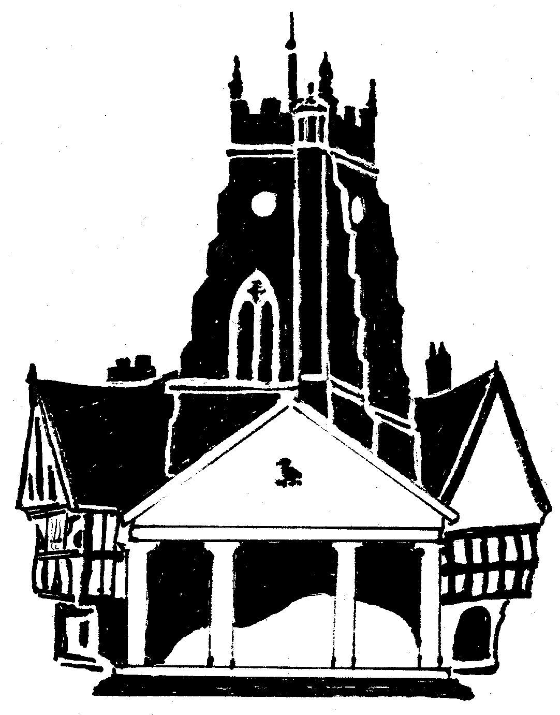  Market Drayton  Town Council
Agenda Item: Christmas Lights

Date: 14 August 2025

Appendix : C068

Budget
There is £5,000 in budget for new lights. The prices below have been obtained from the company who currently install and switch on the lights.
Proposal
To purchase and install new LED rope light around the Buttercross at a cost of £1,075.
To purchase and install hanging stars for the tree in front of the library (lights were purchased for one year last year) at a cost of £1,345.

To fit harness to the branches.  Each harness has several outlets where miniature star motifs  The benefit of this is, is that the  motifs are removed each season and  therefore we would expect a longer life for them. | 