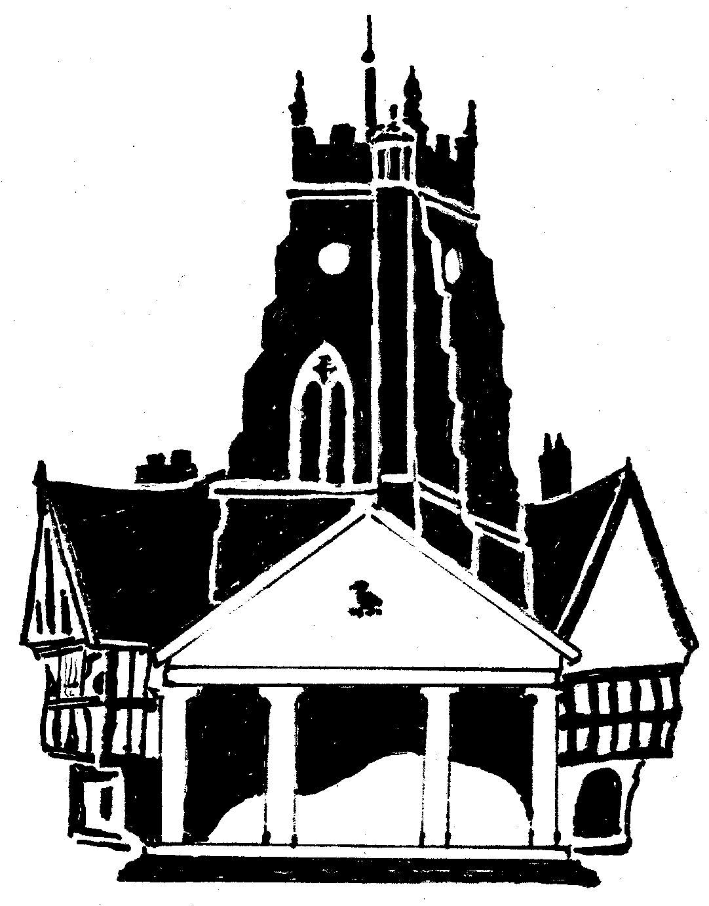

Market Drayton Town Council

Notice of conclusion of audit
Annual Governance & Accountability Return for the year ended 31 March 2025

Sections 20(2) and 25 of the Local Audit and Accountability Act 2014

Accounts and Audit Regulations 2015 (SI 2015/234)

1. The audit of accounts for Market Drayton Town Council for the year ended 31 March 2025 has been completed and the accounts have been published.

2. The Annual Governance & Accountability Return is available for inspection by any local government elector of the area Market Drayton Town Council on application to:

Mrs Kate Harvey – Assistant Clerk / RFO
Town Hall, 18 Frogmore Road,
Market Drayton, Shropshire,
TF9 3AX.

Inspection rights may be exercised:
Monday to Friday
Between 09.00 – 13.00
3. Copies will be provided to any person on payment of £0 for each copy of the Annual Governance & Accountability Return.

Announcement made by: Mrs Kate Harvey, Assistant Clerk / RFO

Date of announcement: 5 September 2025

