Finance & General Purposes Committee Meeting | 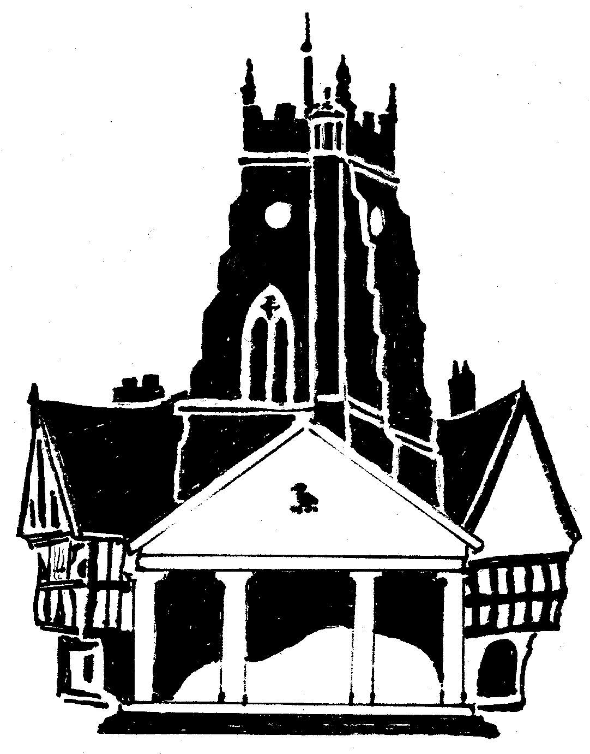  Market Drayton  Town Council
Agenda Item: 11.FG Small Grants

Date: 4 September 2025

Appendix : FG082

Background
At the Finance and General Purposes Committee meeting held on 31 October 2024 it was RESOLVED:
‘The Small Grants budget to be split over four meetings to ensure it is apportioned throughout the financial year’
There was £7,200 allocated in budget; £1,800 to be allocated four times a year.
At the Finance and General Purposes meeting held on the 12 June 2025, £1,799 was allocated leaving a balance of £5,401.
Applications to be Considered
Organisation | Requested Amount  £ | To Fund | Supporting Paperwork  Received | Previous Grant
- Tigers Junior FC | £500 | Replace a set of goals that have recently been vandalised. | Constitution  Bank Statement  Accounts  The club donates money to Georgia Wiliams Trust | No
- Market Drayton Community Enterprise | £500 | Towards holding a festival promoting Health and Wellbeing offering helpful advice, access to a range of services and support. The next event is planned for October at the Festival Drayton. | Consitution  Bank Statement  Accounts  MDCE do not donate money to charity | £500 - 13/06/24  £300 - 15/6/23  £300 - 16/6/22
- Market Drayton Day Centre | £500 | Towards weekly meetings to help towards refreshments, entertainment/guest speakers and games. | Constitution  Bank Statement  Accounts  The club does not donate money to charity | £500 - 13/06/24  £300 - 15/06/23  £300 - 22/4/21
- Victoria Bowling Club | £340 | To purchase a rechargeable Makita hedge trimmer for £339.99 to tidy up the grounds. | Constitution  Bank Statement  Accounts  The club does not donate any money to charity | £500 - 13/6/24
- Market Drayton Methodist Church | £500 | Towards ‘The Extreme Tour’ community event. A skating/scooter/BMX event in the evening of Saturday 13 September at the Skatepark and a music concert in the evening of Sunday14 September at The Zone and park at Longlands. | No Constitution – it’s a Church  Bank Statement  Accounts  The Methodist Church do not donate money to charity | £200 - 30/6/22  (Small Grant)  £670 - 15/6/23  (Large Grant)  £500 - 23/9/24  (The Zone Budget)
 | £2340 | Total Small Grant requests

