Community and Governance Committee Meeting | 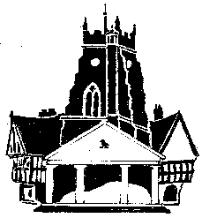  Market Drayton  Town Council
Agenda Item: Correspondance ii Market Drayton Sports
Association.

Date: 18 September 2025

Appendix : CG092

Request
Re: Constitution and Memorandum of agreements
‘Further to yesterdays informal meeting on the above, the main action point out of the meeting was for the setting up of a small working group made up of 2 council representatives and two MDSA board members to review these documents and. consider changes that would be more appropriate for the world today as we find it.
Could I therefore request two nominees from the council that you might wish to put forward as willing and suitable for this small group please?
In advance Steve and I will actively review these documents to get things started, and if you had any observations or comments that would assist the process then we would be pleased to take onboard also.
Thanking you for your assistance in this matter,
Background
At an Extraordinary Council Meeting held on 1 August 2024, it was RESOLVED:
That with immediate effect the two Town Council representatives are removed as Directors of Market Drayton Sports Association. The two nominated Councillors to be Town Council representatives only at Market Drayton Sports Association meetings.
To request that Market Drayton Sports Association amend their Articles of Association to reflect the above.
An informal meeting took place between Town Councillor and the Chair of Market Drayton Sports Association on 27th August 2025 to discuss the removal of the directors and how the Town Council and Market Drayton Sports Association will continue to work together.
To Consider
Nominating two Councillors to the Market Drayton Sports Association working group to review their Constitution and Memorandum of agreements.

