Finance & General Purposes Committee Meeting | 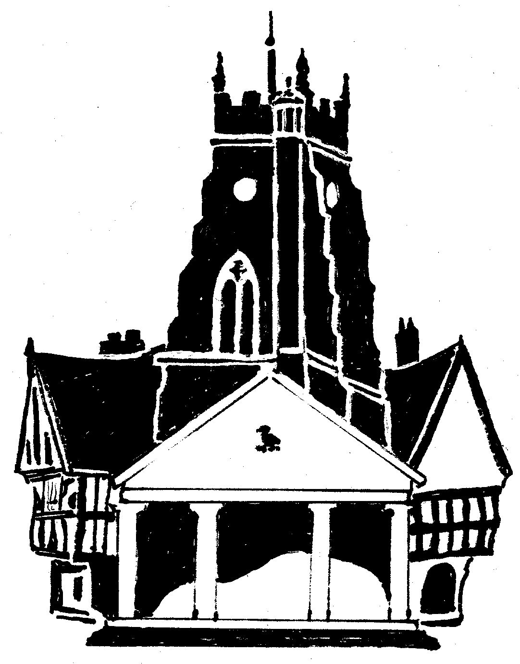  Market Drayton  Town Council
Agenda Item: 11.FG Small Grants

Date: 30 October 2025

Appendix : FG113

Background
At the Finance and General Purposes Committee meeting held on 31 October 2024 it was RESOLVED:
‘The Small Grants budget to be split over four meetings to ensure it is apportioned throughout the financial year’
There was £7,200 allocated in budget; £1,800 to be allocated four times a year.
At the Finance and General Purposes meeting held on the 12 June 2025, £1,799, at the meeting held on 4th September 2025, £1,798 was allocated leaving a balance of £3,603.
Applications to be Considered
Organisation | Requested Amount  £ | To Fund | Supporting Paperwork  Received | Previous Grant
- Drayton Civic Society & Museum | £500 | Venue hire and catering for Suffragette afternoon tea (£150) - £12 per head.  Room hire for Meet the Historians event (£102)  Room hire and refreshments other events  Publicity and printing  Speakers costs (if applicable)  Competition prizes  Craft materials, decorations & banners | Constitution  Bank Statement  Accounts  The club does not donate to charity | 2024/25 £1,000 towards roof repairs
 | £500 | Total Small Grant requests

