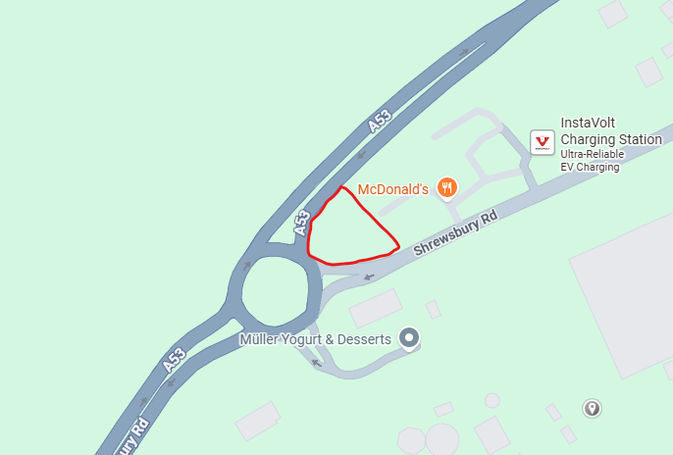
12. Area by roundabout, A53 Shrewsbury Road Entrance

