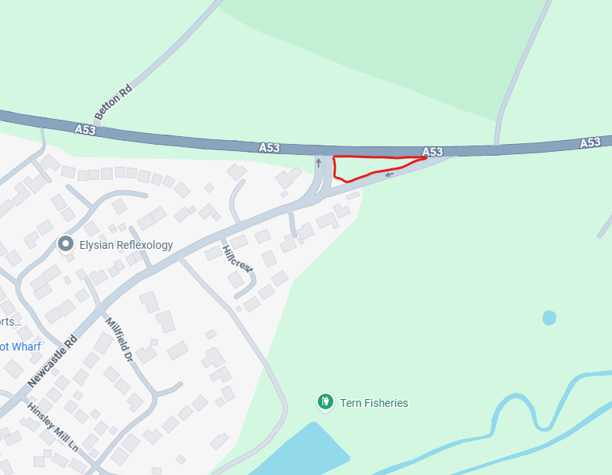
13. Area by roundabout, A53 Newcastle Road entrance to Town

