Services and Facilities Committee Meeting | 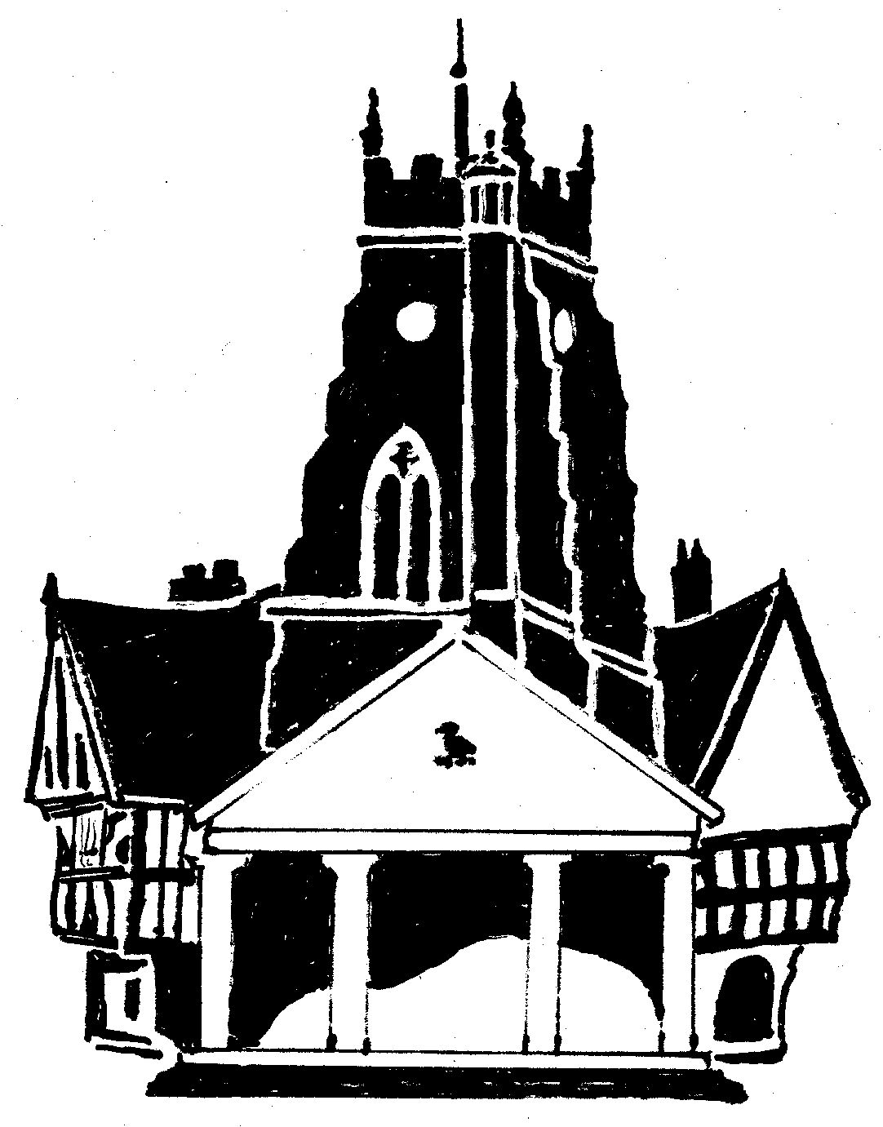  Market Drayton  Town Council
Agenda Item: Youth Club

Date: 27 November 2025

Appendix : SF137

Background
The Town Council currently pay for weekly junior and senior youth club sessions which are run by SYA at the Phoenix Centre and a Wednesday evening.
The junior session (10-12 yrs) is held from 5.15pm to 6.45pm and is very well attended. The senior session (13 yrs and over) is from 7.00pm to 8.30pm, numbers to this session are lower.
The costs are for:
- 2 x 1.5 hour session (plus 0.5 hour for setting up and cleaning up)
- Term time only (39 weeks)
- 3 staff + management support

The current costs are:
Session | Ex VAT | Description | Inc room hire
Junior and Senior back to back | £20,600 | Without trips | £22,160

The costs for 2026/27 are:
The below table sets out the cost to provide the two youth club sessions. There is also the option to pay for trips. The cost to hire the Phoenix Centre is currently £10 per hour.
Market Drayton Quote for 26/27 | Ex VAT | Description | Inc room hire
Junior & Senior back to back | £25,100.00 | with trips | £26,660
Junior & Senior back to back | £21,000.00 | Without trips | £22,560

To consider:
- Continuing to pay SYA to provide two weekly, term time, youth club sessions.

