Finance and General Purposes Committee Meeting | 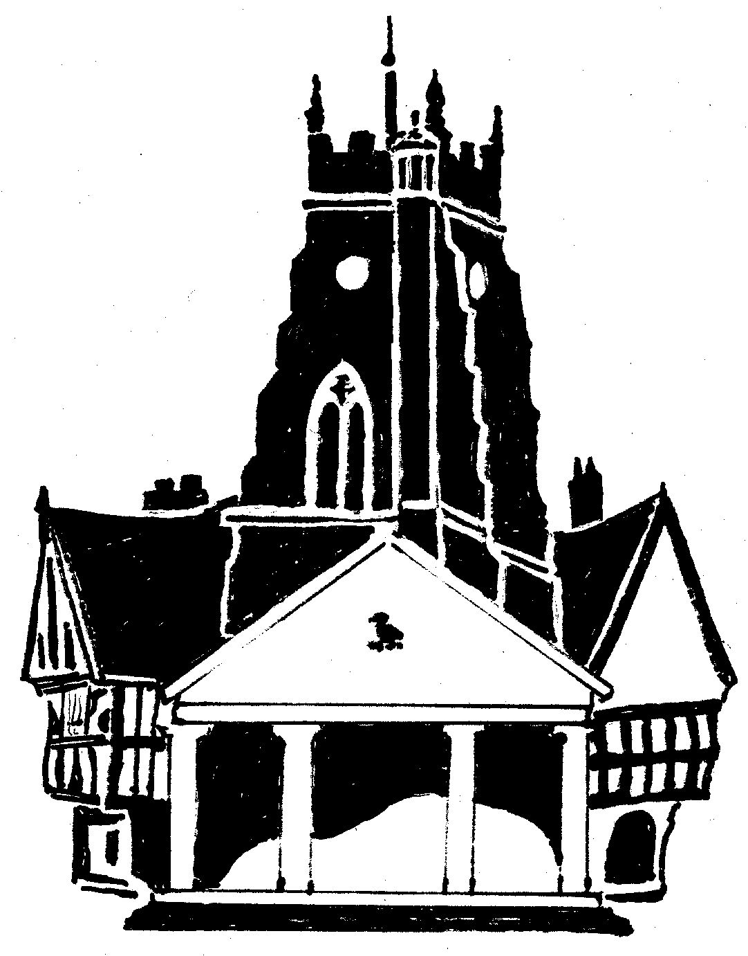  Market Drayton  Town Council
Agenda Item: Budget 2026-27

Date: 11 December 2025

Appendix : FG145

Community and Governance Budget
Cost Centre 301 | Description | Budget 2024/5 | Proposed Budget 2025/26 | Proposed Budget  2026/27
4017 | Police Panel | 1,500 | 0 | 0
4322 | Community Support and Events | 5,000 | 5,000 | 5,000
4323 | Community & Governance | 5,000 | 5,000 | 5,000
4326 | Citizens Advice Bureau | 6,000 | 5,000 | 5,500 | In line with funding provided last year
4968 | Public Transport | 6,000 | 6,500 | 6,600 | To continue to subsidise the Saturday Town Bus Service and/or support other local transport initiatives.
4969 | Communications and Promotion | 4,000 | 70,000 | 0
4971 | Make it Market Drayton | 0 | 0 | 20,000 | To pay for the administration of Make it Market Drayton, events, training etc.
4972 | Town Action Plan Projects | 0 | 0 | 50,000 | To pay for Visit Shropshire and implementation of Town Action Plan projects.
Total |  | 27,500 | 91,500 | 92,100

