Finance and General Purposes Committee Meeting | 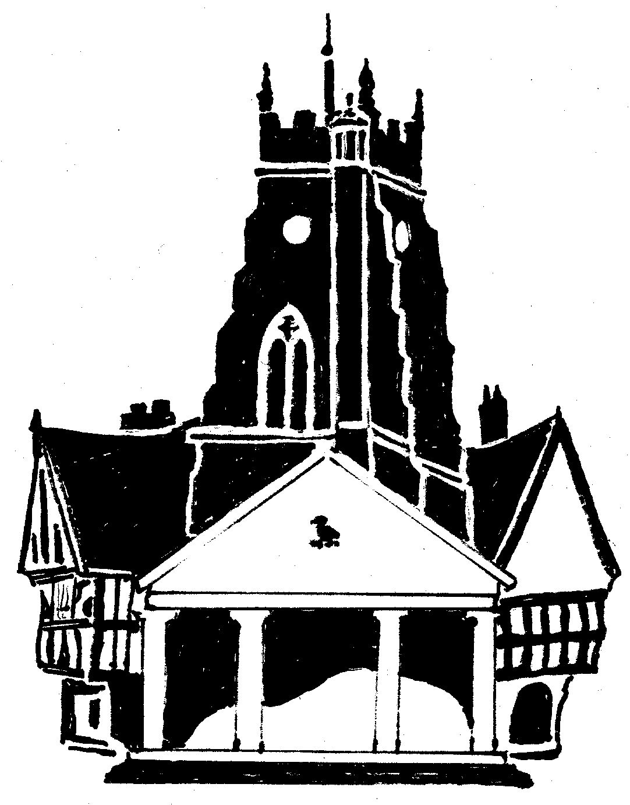  Market Drayton  Town Council
Agenda Item: Budget 2026-2027
Date: 11 December 2025
Appendix : FG145

Finance Budget
Cost Centre | Description | Budget  2024/25 | Budget  2025/26 | Draft Budget  2026/27 | Variance explanation
201 | Administration | 155,220 | 165,053 | 171,710 | Increase in working hours/Salary increases  Increase due to room hire costs for Council Meetings
202 | Admin and Outside Staff Accommodation | 30,470 | 30,450 | 29,790
203 | Civic Activities | 29,725 | 29,825 | 29,375
206 | Miscellaneous (PWLB) | 4,800 | 4,600 | 4,200
207 | Small Grants | 6,500 | 7,200 | 7,200
Total |  | 226,715 | 237,128 | 242,275 | £4,887 increase

