Finance & General Purposes Committee Meeting | 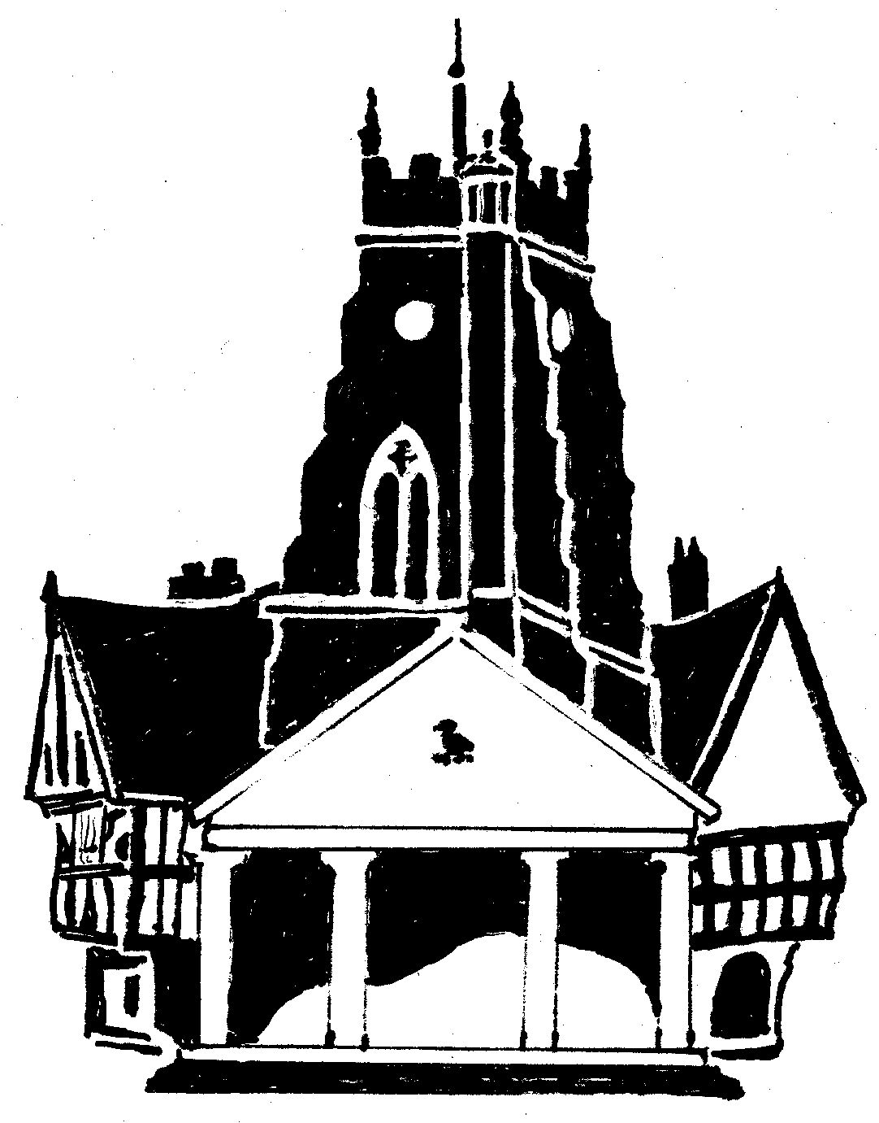  Market Drayton  Town Council
Agenda Item: 11.FG Small Grants

Date: 12 February 2026

Appendix : FG173

Background
At the Finance and General Purposes Committee meeting held on 31 October 2024 it was RESOLVED:
‘The Small Grants budget to be split over four meetings to ensure it is apportioned throughout the financial year’
There was £7,200 allocated in budget; £1,800 to be allocated four times a year.
At the Finance and General Purposes meeting held on: 12 June 2025 £1,799 was allocated
4 Sept 2025 £1,798 was allocated
30 Oct 2025 £500 was allocated £3,103 Remaining
Applications to be Considered
Organisation | Requested Amount  £ | To Fund | Supporting Paperwork  Received | Previous Grant
Creative Drayton | £500 | To be able to hold artistic workshops most Saturdays in the Market Hall. The grant will wnsure these can be offered at an affordable price to enable them to be accessible to all in the community. | Constitution  Bank Statement  Accounts  The club does not donate to charity | No
North Solap Wheelers Community Bus | £500 | Towards the running costs of running the community bus to Market Drayton every Wednesday. | Constitution  Bank Statement  Accounts  The Group does not donate any money to charity | Yes  05/09/24 £325

