Services and Facilities Committee Meeting |   Market Drayton  Town Council
Agenda Item: Town Park Play Area - Roundabout

Date: 12 March 2026

Appendix : SF191

The roundabout on the Town Park play area needs repairing. The roundabout is currently fenced off for safety reasons.
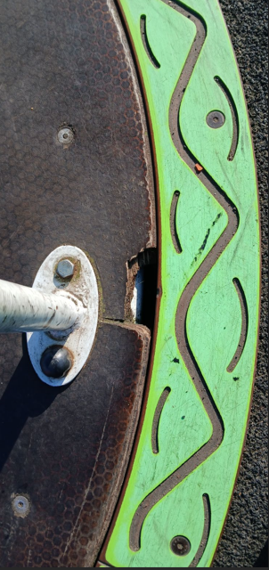
A quote has been received to:
- Strip down Roundabout
- Fit new Riv Nuts
- renew fasteners
- Supply and fit new Deck Boards

Total Cost £1765.00 plus vat
To consider accepting the above quote to be paid for from General Reserves; there is no money in budget.

