Services and Facilities Committee Meeting |   Market Drayton  Town Council
Agenda Item: Town Park Play Area

Date: 12 March 2026

Appendix : SF192

The Town Council is continuing to refurbish the parks and play areas in the town. The next site is the Town Park. Funding has been allocated from budget, earmarked reserves and neighbourhood fund, the total budget available £119,000.

The proposal is to extend the play area by re-routing the current pathway. The additional space will allow for new play equipment to be installed and for an area where young children can safely run around within the enclosed area.

It is proposed to undertake the project in two stages; Stage one being the groundworks to relocate the pathway and fencing. Stage two the refurbishment of old play equipment and the provision and installation of new play equipment.

Stage One

The fence to be relocated to make a new boundary fence for the play area, the existing fence to be reused where possible and a new gate installed. The path will be re-routed to follow the new boundary.

The area under the tree will be included in the new play area; the hedge, marked in green, will be reduced in height to improve visibility to that area.

To utilise the space better the existing gate will be related further along the fence, as marked in yellow, not only will this provide better safety for the children as it is further away from the entrance onto the road, it will free up a space to install a new piece of play equipment

There are two options as to how to re-route the pathway.

(Please note these drawings are for illustration purposes only and not to scale).

Option one
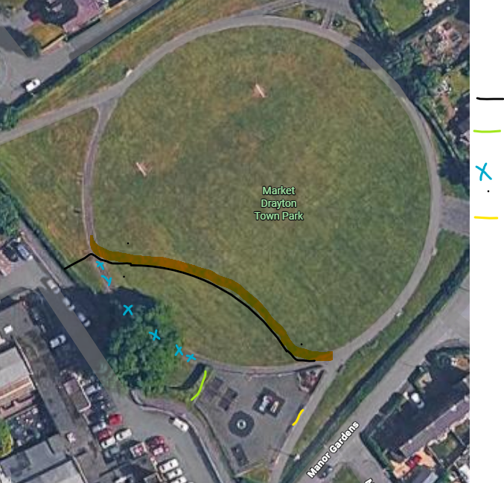
New path

New Fence

Hedge height reduced

Remove pathway

Relocation of the existing gate

Option Two
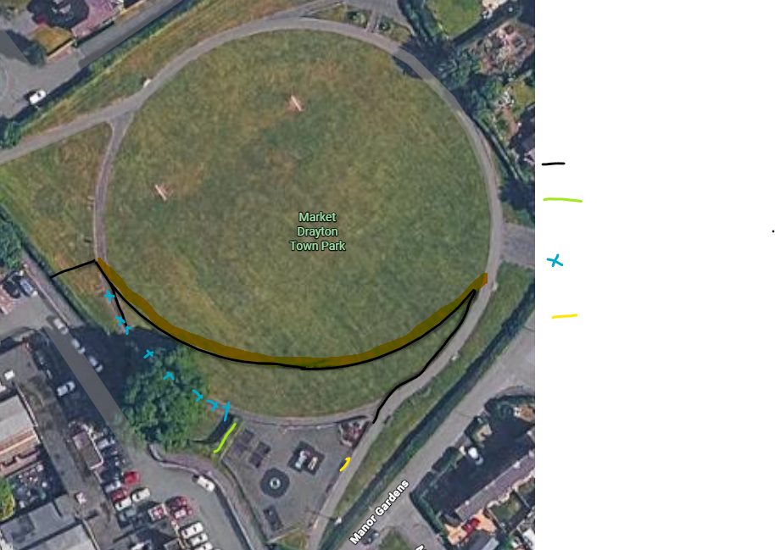

New path

New Fence

Hedge height reduced

Remove pathway

Relocation of the existing gate

Stage Two
The refurbishment and installation of new play equipment
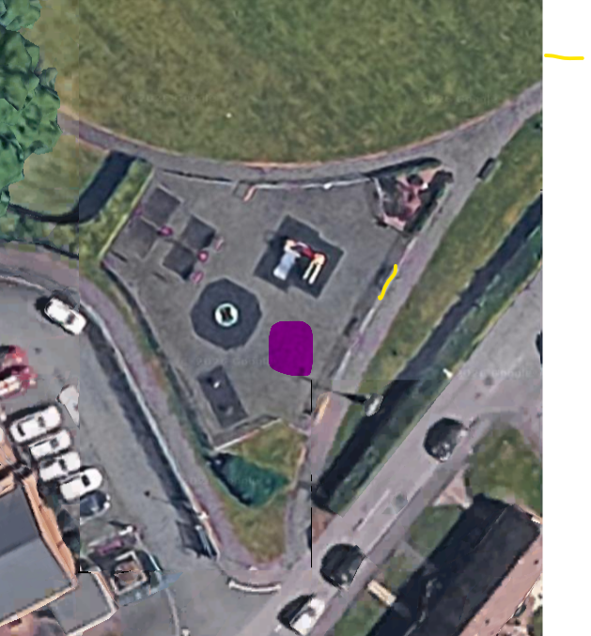
6
1 Gate relocated
2 Swings to be repainted
3 Slide to be repainted
4 Roundabout to remain
5 Rockers to be replaced with a see saw
6 New piece of equipment/painted floor games
7 Small goalpost
8 New equipment
5
4
2

1
8
7
3
It is proposed to refurbish as much of the current equipment as possible, repainting the slide and swings and the barriers around the swings to have sensory boards installed on them (2&3).

The roundabout will remain (4) and the rockers will be replaced with a see-saw (5).

The relocation of the gate (1) will up free space to install a new piece of play equipment (6).

A small goalpost to be installed under the tree (7).

New equipment, with grass matting underneath, will be installed on the grassed area (8).

Consultation

The town park is a well used area, before work commences it is proposed that the plan to relocate the pathway and extend the play area are widely publicised.

It is also proposed to involve the children from the infant school regarding the design of the new area and new equipment to be installed.

