Council Meeting
21 May 2026
Appendix: CO6


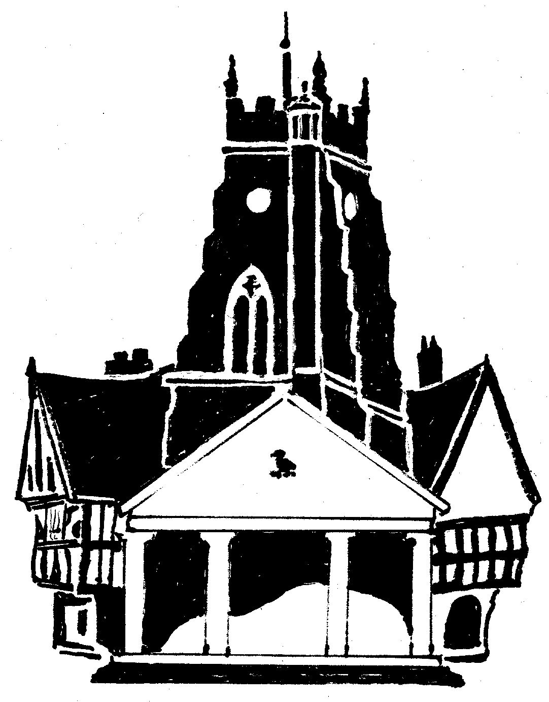

MARKET DRAYTON TOWN COUNCIL

COUNCILLOR-OFFICER PROTOCOL

Contents
INTRODUCTION.................................................................................................................................. 2

BACKGROUND ................................................................................................................................... 3

ROLES OF COUNCILLORS AND OFFICERS ................................................................................... 3

Councillors........................................................................................................................................ 3

Chairs and vice-chairs of council and committees .......................................................................... 5

Officers ............................................................................................................................................. 5

The Relationship: General ............................................................................................................... 6

Expectations..................................................................................................................................... 7

Some general principles................................................................................................................... 7

COUNCILLORS’ ACCESS TO INFORMATION AND TO COUNCIL DOCUMENTS ........................ 8

CORRESPONDENCE ......................................................................................................................... 8

PRESS AND MEDIA ............................................................................................................................ 9

IF THINGS GO WRONG ...................................................................................................................10

Procedure for officers:....................................................................................................................10

Procedure for councillors: ..............................................................................................................10
INTRODUCTION
The purpose of this Protocol is to guide councillors and officers of the council in their
relations with one another. The Protocol’s intention is to build and maintain good working relationships between councillors and officers as they work together. Employees who are required to give advice to councillors are referred to as “officers” throughout.

A strong, constructive, and trusting relationship between councillors and officers is essential to the effective and efficient working of the council.

This Protocol also seeks to reflect the principles underlying the Code of Conduct which applies to councillors and the employment terms and conditions of officers. The shared objective is to enhance and maintain the integrity (real and perceived) of local government.

The following extract from the Local Government Association guidance on the 2020 Model councillor Code of Conduct states that:

“Both councillors and officers are servants of the public and are indispensable to one another. Together, they bring the critical skills, experience and knowledge required to manage an effective local authority.

At the heart of this relationship, is the importance of mutual respect. councillor- officer relationships should be conducted in a positive and constructive way. Therefore, it is important that any dealings between councillors and officers should observe reasonable standards of courtesy, should show mutual appreciation of the importance of their respective roles and that neither party should seek to take unfair advantage of their position or seek to exert undue influence on the other party.

councillors provide a democratic mandate to the local authority and are responsible to the electorate whom they represent. They set their local authority’s policy framework, ensure that services and policies are delivered and scrutinise local authority services.

[Councillors of the executive,] Chairs and vice chairs of committees have additional responsibilities. These responsibilities will result in increased expectations and relationships with officers that are more complex. Such councillors must still respect the impartiality of officers and must not ask them to undertake work of a party- political nature or compromise their position with other councillors or other officers.

Officers provide the professional advice and managerial expertise and information needed for decision making by councillors and to deliver the policy framework agreed by councillors. They are responsible for implementing decisions of councillors and the day-to-day administration of the local authority.

The roles are very different but need to work in a complementary way.

It is important for both sides to respect these differences and ensure that they work in harmony. Getting that relationship right is an important skill. That is why the code requires councillors to respect an officer’s impartiality and professional expertise. In
turn officers should respect a councillor’s democratic mandate as the people accountable to the public for the work of the local authority. It is also important for a local authority to have a councillor-officer protocol which sets out how this relationship works and what both councillors and officers can expect in terms of mutual respect and good working relationships.”

This Protocol covers:

• The respective roles and responsibilities of the councillors and the officer;
• Relationships between councillors and officers;
• Where/who a councillor or an officer should go to if they have concerns;
• Who is responsible for making decisions.

BACKGROUND
This Protocol is intended to assist councillors and officers, in approaching some of the
sensitive circumstances which arise in a challenging working environment.

The reputation and integrity of the council is significantly influenced by the effectiveness of councillors and the officer working together to support each other’s roles.

The aim is effective and professional working relationships characterised by mutual trust, respect and courtesy. Overly close personal familiarity between councillors and officers is not recommended as it has the potential to damage this relationship

ROLES OF COUNCILLORS AND OFFICERS
The respective roles of councillors and officers can be summarised as follows:

• Councillors and officers are servants of the public and they are indispensable to one and other, but their responsibilities are distinct.
• Councillors are responsible to the electorate and serve only for their term of office.
• Officers are responsible to the council. Their job is to give advice to councillors and to the council, and to carry out the council’s work under the direction and control of the council and relevant committees.

Councillors
Councillors have four main areas of responsibility:

• To determine council policy and provide community leadership;
• To monitor and review council performance in implementing policies and delivering services;
• To represent the council externally; and
• To act as advocates for their constituents.

All councillors have the same rights and obligations in their relationship with the officer, regardless of their status and should be treated equally.
Councillors should not involve themselves in the day to day running of the council. This is the officer’s responsibility, and the officer will be acting on instructions from the council or its committees, within an agreed job description.

In line with the councillors’ Code of Conduct, a councillor must treat others with respect, must not bully or harass people and must not do anything which compromises, or is likely to compromise, the impartiality of those who work for, or on behalf of, the council.

Officers can expect councillors:

• to give strategic leadership and direction and to seek to further their agreed policies and objectives with the understanding that councillors have the right to take the final decision on issues based on advice
• to act within the policies, practices, processes and conventions established by the council
• to work constructively in partnership with officers acknowledging their separate and distinct roles and responsibilities
• to understand and support the respective roles and responsibilities of officers and their associated workloads, pressures and reporting lines
• to treat them fairly and with respect, dignity and courtesy
• to act with integrity, to give support and to respect appropriate confidentiality
• to recognise that officers do not work under the instruction of individual councillors or groups
• not to subject them to bullying, intimidation, harassment, or put them under undue pressure.
• to treat all officers, partners (those external people with whom the council works) and members of the public equally, and not discriminate based on any characteristic such as age, sex, race, sexual orientation, gender identity, disability or religion.
• not to request officers to exercise discretion which involves acting outside the council’s policies and procedures
• not to authorise, initiate, or certify any financial transactions or to enter into any contract, agreement or undertaking on behalf of the council or in their role as a councillor without proper and lawful authority
• not to use their position or relationship with officers to advance their personal interest or those of others or to influence decisions improperly
• to comply at all times with the councillors’ Code of Conduct, the law, and such other policies, procedures, protocols and conventions agreed by the council.
• respect the impartiality of officers and do not undermine their role in carrying out their duties
• do not ask officers to undertake work, or act in a way, which seeks to support or benefit a particular political party or gives rise to an officer being criticised for operating in a party-political manner
• do not ask officers to exceed their authority where that authority is given
Chairs and vice-chairs of council and committees
Chairs and vice-chairs have additional responsibilities as delegated by the council. These responsibilities mean that they may have to have a closer working relationship with employees than other councillors do. However, they must still respect the impartiality of officers and must not ask them to undertake work or anything else which would prejudice their impartiality.

Officers
The primary role of officers is to advise, inform and support all members and to implement the agreed policies of the council.

Officers are responsible for day-to-day managerial and operational decisions within the council, including directing and overseeing the work of any more junior officers. councillors should avoid inappropriate involvement in such matters.

In performing their role officers will act professionally, impartially and with neutrality. Whilst officers will respect a councillor’s view on an issue, the officer should not be influenced or pressured to make comments, or recommendations which are contrary to their professional judgement or views.

Officers must:

• implement decisions of the council and its committees which are lawful, which have been properly approved in accordance with the requirements of the law and are
duly recorded. This includes respecting the decisions made, regardless of any different advice given to the council or whether the decision differs from the officer’s view.
• work in partnership with councillors in an impartial and professional manner
• treat councillors fairly and with respect, dignity and courtesy
• treat all councillors, partners and members of the public equally, and not discriminate based on any characteristic such as age, sex, race, sexual orientation, gender identity, disability or religion.
• assist and advise all parts of the council. Officers must always act to the best of their abilities in the best interests of the authority as expressed in the council’s formal decisions.
• respond to enquiries and complaints in accordance with the council’s standards
protocol
• be alert to issues which are, or are likely to be, contentious or politically sensitive, and be aware of the implications for councillors, the media or other sections of the public.
• act with honesty, respect, dignity and courtesy at all times
• provide support and learning and development opportunities for councillors to help them in performing their various roles in line with the council’s training and development policy
• not seek to use their relationship with councillors to advance their personal interests or to influence decisions improperly
• comply, at all times, with the Officers’ Code of Conduct, and such other policies or procedures approved by the council

Officers have the right not to support councillors in any role other than that of councillor, and not to engage in actions incompatible with this Protocol.

In giving advice to councillors, and in preparing and presenting reports, it is the responsibility of the officer to express his/her own professional views and recommendations. An officer may report the views of individual councillors on an issue, but the recommendation should be the officer’s own. If a councillor wishes to express a contrary view they should not pressurise the officer to make a recommendation contrary to the officer’s professional view, nor victimise an officer for discharging his/her responsibilities.

There are exceptional circumstances where a councillor can fulfil the role of officer, for example where there is a vacancy. This can only be done if the councillor is not paid for the role and should only ever be short-term while the council seeks to fill a vacancy. There will need to be a particular clear understanding of when the councillor is acting as a councillor and when acting as the Proper Officer.

The Relationship: General
Councillors and officers are indispensable to one another. However, their responsibilities are distinct. councillors are accountable to the public, whereas officers are accountable to the council as a whole.

At the heart of this Protocol is the importance of mutual respect and also of civility. councillor/officer relationships are to be conducted in a positive and constructive way. Therefore, it is important that any dealings between councillors and officers should observe standards of courtesy and that neither party should seek to take unfair advantage of their position nor seek to exert undue influence on the other party.

Individual councillors should not actively seek to undermine majority decisions of the corporate body, as this could then bring them into conflict with officers who have been charged with promoting and implementing the council’s collectively-determined course of action.

Councillors should not raise matters relating to the conduct or capability of an officer, or of officers collectively, in a manner that is incompatible with this Protocol at meetings held in public or on social media. This is a long-standing tradition in public service. An officer has no means of responding to criticisms like this in public.

A councillor who is unhappy about the actions taken by, or conduct of, an officer should:

• avoid personal attacks on, or abuse of, the officer at all times
• ensure that any criticism is well founded and constructive
• ensure that any criticism is made in private
• take up the concern with the chair
Neither should an officer raise with a councillor matters relating to the conduct or capability of another councillor or officer or to the internal management of the council in a manner that is incompatible with the objectives of this Protocol.

Potential breaches of this Protocol are considered below.

Expectations
All councillors can expect:

• A commitment from officers to the council as a whole, and not to any individual councillor, group of councillors or political group;
• A working partnership;
• Officers to understand and support respective roles, workloads and pressures;
• A timely response from officers to enquiries and complaints;
• Officer’s professional and impartial advice, not influenced by political views or personal preferences;
• Timely, up to date, information on matters that can reasonably be considered appropriate and relevant to their needs, having regard to any individual responsibilities or positions that they hold;
• Officers to be aware of and sensitive to the public and political environment locally;
• Respect, courtesy, integrity and appropriate confidentiality from officers and other councillors;
• Training and development opportunities to help them carry out their role effectively;
• Not to have personal issues raised with them by officers outside the council’s
agreed procedures;
• That officers will not use their contact with councillors to advance their personal interests or to influence decisions improperly.

Officers can expect from councillors:

• A working partnership;
• An understanding of, and support for, respective roles, workloads and pressures;
• Leadership and direction;
• Respect, courtesy, integrity and appropriate confidentiality;
• Not to be bullied or to be put under undue pressure;
• That councillors will not use their position or relationship with officers to advance their personal interests or those of others or to influence decisions improperly;
• That councillors will at all times comply with the council’s adopted Code of Conduct.

Some general principles
Close personal relationships between councillors and officers can confuse their separate roles and get in the way of the proper conduct of council business, not least by creating a perception in others that a particular councillor or officer is getting preferential treatment.

Special relationships with particular individuals are not recommended as it can create suspicion that an employee favours that councillor above others.
The Proper Officer (usually called the Clerk) is the head of paid services and has a line- management responsibility to all other staff. Communications should be made directly
with the Proper Officer, unless it is agreed by the Proper Officer that such communications may take place directly with other officers over a particular matter. Councillors should not give instructions directly to the Proper Officer’s staff without the express approval of the Proper Officer.

COUNCILLORS’ ACCESS TO INFORMATION AND TO COUNCIL DOCUMENTS
Councillors are free to approach officers to provide them with such information,
explanation and advice as they may reasonably need in order to assist them in discharging their role as members of the council. This can range from a request for general information about some aspect of the council’s activities to a request for specific information on behalf of a constituent. Such approaches should normally be directed to the Officer.

The legal rights of councillors to inspect council documents are covered partly by statute and partly by the common law.

The common law right of councillors is based on the principle that any member has a prima facie right to inspect council documents so far as their access to the documents is reasonably necessary to enable the member properly to perform their duties as a member of the council. This principle is commonly referred to as the “need to know” principle.

The exercise of this common law right depends therefore upon the councillor’s ability to demonstrate that they have the necessary “need to know”. In this respect a member has no right to “a roving commission” to go and examine documents of the council. Mere curiosity is not sufficient. The crucial question is the determination of the “need to know”. This question must be determined by the officer.

In some circumstances (e.g. a committee member wishing to inspect documents relating
to the functions of that committee) a councillor’s “need to know” will normally be presumed. In other circumstances (e.g. a councillor wishing to inspect documents which contain personal information about third parties) a councillor will normally be expected to justify the request in specific terms. Any council information provided to a councillor must only be used by the councillor for the purpose for which it was provided i.e. in connection with the proper performance of the councillor’s duties as a member of the council.

For completeness, councillors do, of course, have the same right as any other member of the public to make requests for information under the Freedom of Information Act 2000.

CORRESPONDENCE
Correspondence between an individual councillor and an officer should not normally be
copied (by the officer) to any other councillor. Where exceptionally it is necessary to copy the correspondence to another councillor, this should be made clear to the original councillor. In other words, a system of “silent copies” should not be employed. Acknowledging that the “BCC” system of e-mailing is used, it should be made clear at the
foot of any e-mails if another councillor has received an e-mail by adding “CC councillor
X.”

Official letters or emails on behalf of the council should normally be sent out under the name of the officer, rather than under the name of a councillor. It may be appropriate in certain circumstances (e.g. representations to a Government Minister) for a letter or email to appear over the name of the chair, but this should be the exception rather than the norm. Letters or emails which, for example, create obligations or give instructions on behalf of the council should never be sent out in the name of a councillor.

Correspondence to individual councillors from officers should not be sent or copied to complainants or other third parties if they are marked “confidential”. In doing so, the relevant officer should seek to make clear what is to be treated as being shared with the councillor in confidence only and why that is so.

PRESS AND MEDIA
Councils are accountable to their electorate. Accountability requires local understanding.
This will be promoted by the council, explaining its objectives and policies to the electors and customers. Councils use publicity to keep the public informed and to encourage public participation. The council needs to tell the public about the services it provides. Good effective publicity should aim to improve public awareness of the council’s activities. Publicity is a sensitive matter in any political environment because of the impact it can have. Expenditure on publicity can be significant. It is essential to ensure that decisions on publicity are properly made in accordance with the Code of Recommended Practice on Local Authority Publicity and the council’s Media Protocol.

The officer may respond to press enquiries but should confine any comments to the facts of the subject matter and the professional aspects of the function concerned. On no account must an officer expressly or impliedly make any political opinion, comment or statement.

Any press release that may be necessary to clarify the council’s position in relation to disputes, major planning developments, court issues or individuals’ complaints should be approved by the officer.

The chair (or chair of a committee) may act as spokespersons for the council in responding to the press and media and making public statements on behalf of the council but should liaise with the officer on all forms of contact with the press and media. The council may also appoint individual councillors as spokespeople where there is an area of particular expertise but this should only be done with the agreement of the council.

The council must comply with the provisions of the Local Government Act 1986 (“the Act”) regarding publicity. All media relations work will comply with the national Code of Practice for Local Government Publicity. The Code is statutory guidance and the council must have regard to it and follow its provisions when making any decision on publicity.
The LGA has produced useful guidance on the Publicity Code - https://www.local.gov.uk/publications/short-guide-publicity-during-pre-election-period

For more detailed information and guidance regarding the role of councillors in connection with the use of social media, reference should be made to the council’s Social Media Protocol where there is one in place.

IF THINGS GO WRONG
Procedure for officers:
From time to time the relationship between councillors and the officer (or other employees) may break down or become strained. Whilst it is always preferable to resolve matters informally, it is important that the council adopts a formal grievance protocol or procedure.

The principal council’s monitoring officer may be able to offer a mediation/conciliation role or it may be necessary to seek independent advice. The chair of the council should not attempt to deal with grievances or work related performance or line management issues on their own. The council should delegate authority to a small group of councillors to deal with all personnel matters.

The law requires all employers to have disciplinary and grievance procedures. Adopting a grievance procedure enables individual employees to raise concerns, problems or complaints about their employment in an open and fair way.

Where the matter relates to a formal written complaint alleging a breach of the councillors’ Code of Conduct the matter must be referred to the principal council’s monitoring officer in the first instance in line with the Localism Act 2011. The council may however try to
resolve any concerns raised informally before they become a formal written allegation.

Procedure for councillors:
If a councillor is dissatisfied with the conduct, behaviour or performance of the officer or another employee, the matter should be reported to the chair and then raised with the officer in the first instance. If the matter cannot be resolved informally, it may be necessary to invoke the council’s disciplinary procedure.

