Services and Facilities Meeting |   Market Drayton  Town Council
Agenda Item: Play Areas

Date: 4 June 2026

Appendix : SF018

Background

The wet pour under the spinning dish on the Dalelands has lifted. It was laid as part of the park upgrade in 2023.
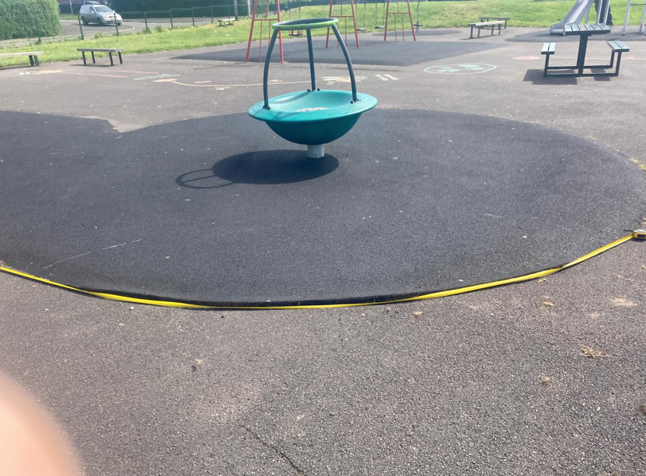

Information

Three companies were contacted to quote for the repairs; two quotes have been received.

Quote | Price (excluding VAT)
A | £1,950
B | £1,643

To Consider

To consider the quotes

