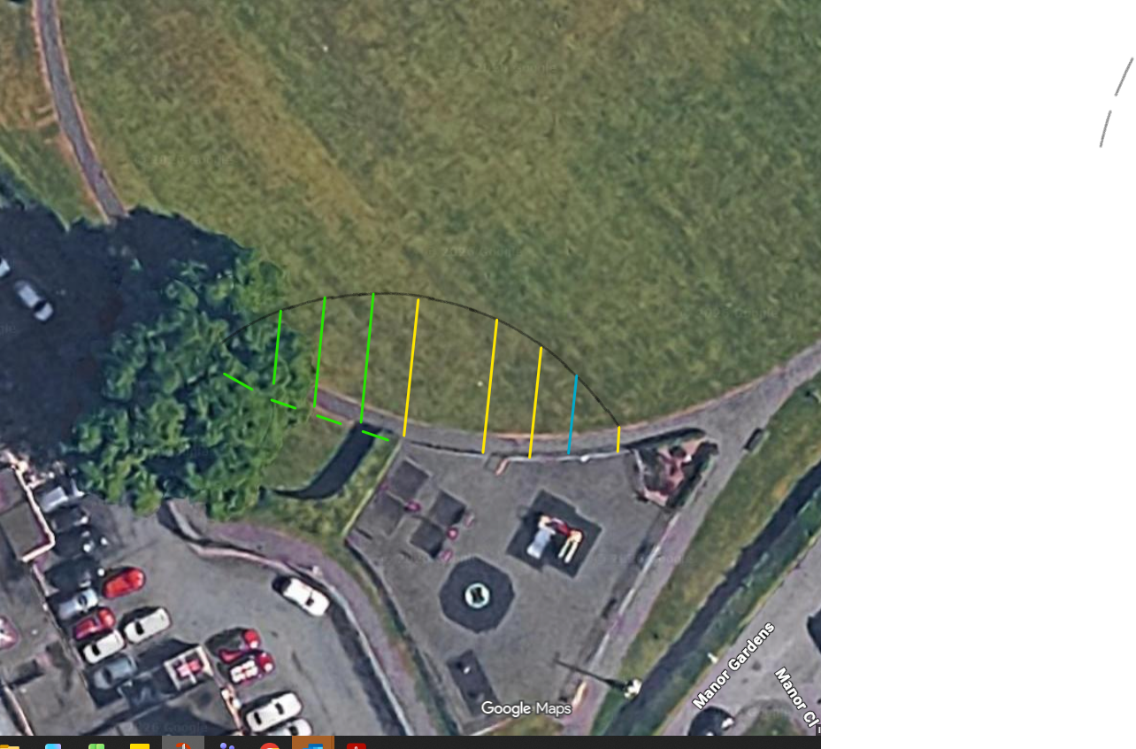
Fencing to be removed and reinstalled
Town Park Extension – Invitation to Quote - Attachment A
- All measurements are in Meters
- All measurements are perpendicular
- The pathway will follow the fence line and be curved to create a seamless flow to the existing path at each end.
- Pathway to be 2m width
- The fence under the tree to go up to the hedge.
2
7
9
11
12
11
9
7
Measurement from the corresponding fence post colour
Each measurement is 5 mtrs apart (ends just past the tree)

