Council Meeting |   Market Drayton  Town Council
Agenda Item: Mechanical Sweeper

Date: 16 July 2026

Appendix : CO047

BACKGROUND
At the Services and Facilities meeting on the 4 June 2026 it was resolved to:
To investigate the cost of having a contractor to provide a mechanical road sweeping service within the town centre. The costs to be brought back to the next suitable meeting.

LOCATIONS
Two quotes have been received to clean the town centre streets as shown out below.
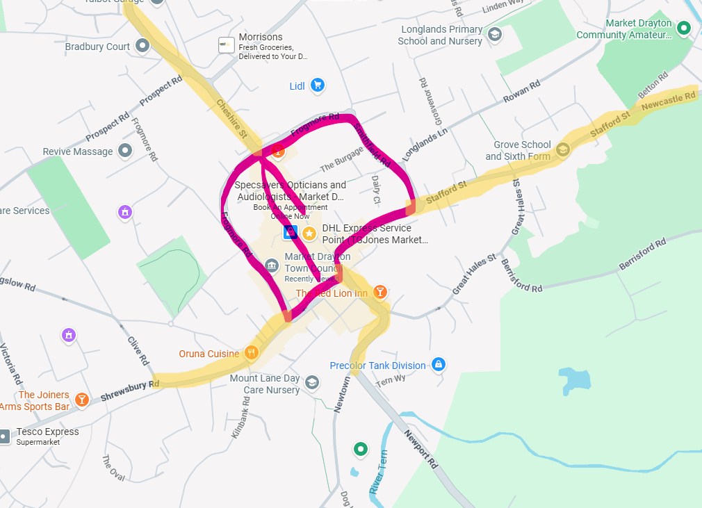
QUOTES
Two quotes have been received based on 6 cleans per year:

Quote A
Operated sweeper @ £60.00 per hour,= estimate 4-6 hours on site to complete works.
Travel to and from site @ £90.00 = charged at 45 minutes each way.
Disposal of waste from site @ £88.62 per tonne, minimum charge = 1 tonne.
Total cost per clean at 4 hours = £418

Quote B
To do the works requested 6 times a year for 3 hours each visit with 1 hour travel plus a mimiimum of 1 tonne waste taken away will be as below
Hours working plus 1 hour travel @ £50 per hour = £200
Waste removed @ £135 per tonne [ min 1 tonne ]
Total = £335

BUDGET
Payment for 2026/27 could be from the Town Action Plan Projects budget. For the next financial year conversations to take place with SC regarding a financial contribution towards the cost.

