Finance & General Purposes Committee Meeting | 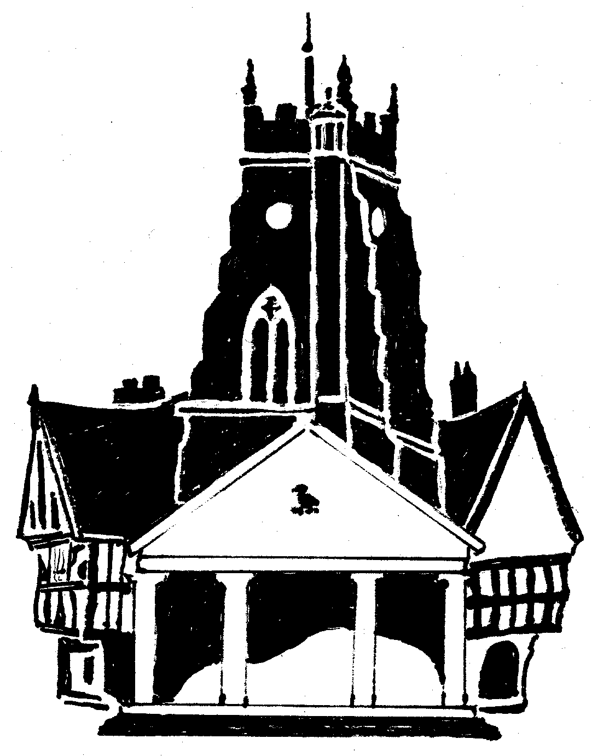  Market Drayton  Town Council
Agenda Item: 13.FG Small Grants

Date: 3 September 2026

Appendix : FG063

Background
At the Finance and General Purposes Committee meeting held on 31 October 2024 it was RESOLVED:
‘The Small Grants budget to be split over four meetings to ensure it is apportioned throughout the financial year’
There is £7,200 allocated in budget; £1,800 to be allocated four times a year.
There is currently £5,700 remaining in budget.
Applications to be Considered
Organisation | Requested Amount £ | To Fund | Supporting Paperwork Received | Previous Grant
Lingen Davies Cancer Support | £500 | To part fund two creative art workshops at the Beacon Community Centre on 12/11/26 and 10/12/26 for individuals living with and beyond cancer.  Funds will help pay towards the instructor fees, materials and venue costs. | Constitution  Bank Statement  Accounts  The Group does not donate to charity | No
Community Resource | £500 | To support the delivery of the Hearing Loss Support service in Market Drayton which holds a face-to-face monthly hub at the library. | Constitution  Bank Statement  Accounts  The Group does not donate to charity | No

