Request for permission to install a community electronic screen in the reception of the Town Hall
MDCE is a registered charity (CIO 1178317) based in Market Drayton aiming, amongst other things, to help with improving local social connections.
One of our missions is to site a 55” electronic screen in the centre of town, to promote local events organised by charities, not-for-profit organisations and community activities. This is to help visitors to the town and local residents, who do not have the experience, technology or skills, to access this information via a computer or mobile phone.
We have researched the viability of siting and installing an outdoor or indoor screen and have come to the conclusion that an indoor one is the best option in relation to

- Requirements for Planning Permission & Legal Regulations.
- Structural & Mounting Requirements.
- Electrical & Power Requirements.
- Environmental & Screen Specifications.
- Content & Data Management.
- Security
- Maintenance & Safety Requirements.
- Cost

After evaluating a number of locations, we would like to request permission from the Town Council to site the screen in the reception area of the Town Hall behind the RHS lower windows in the gable above the door.
Market Drayton Community Enterprise are prepared to fund the provision and installation of the screen, manage the remotely operated content and cover any maintenance costs ensuing.

Details of the screen and proposed installation are as follows:-
55" iiyama ProLite LH5565UHSB: 800 nits
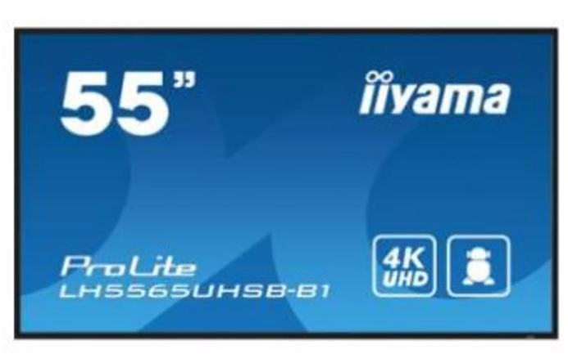

Screen Size | 55"
Resolution | 4K UHD
Brightness | 800 cd/m²
Operating System | Android
Operational Hours | 24/7
Weight | 14.6 kg

Forging Mount Bracket 1035mm: Information
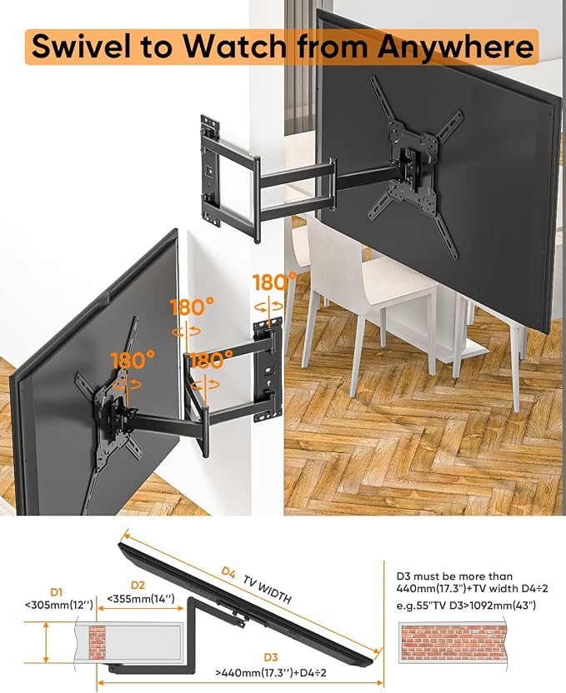Long reach TV Wall

Screen content to be managed using publicity software app ‘Yodeck’, enabling operators to upload content remotely.
Yodeck is a cloud-based digital signage platform widely used in the UK. It offers a tiered subscription model and a free plan for use of a single screen.
The screen will act as a digital noticeboard for the town, displaying:
- Local community events throughout the year
- Club and group meetings
- Festivals, markets and fairs
- Important reminders and alerts
The project’s aim is simple: to help keep everyone informed and connected.

Additional information requested by the Clerk

HI Sue
Here are the full dimensions for the iiyama ProLite LH5565UHSB-B1:
Width: 1237.5 mm (about 124 cm)
Height: 710 mm (71 cm)
Depth: 55 mm (5.5 cm)
Weight of screen: 14.6 kg
Weight with packaging and shipping box: 19.8 kg

Re bracket - The screen needs to be attached to a bracket sited centrally on the brick wall just below the screen. There are only window frames at the level where we want to set up the screen. It would not be practical to attach a bracket to a window frame
Hope this is helpful

